FamilyCompositionServiceV2: Technical ServiceSpecifications

Historiek van de revisies
Versie | Date | Beschrijving | Auteur(s)
2.0 |  | Eerste versie voor “V2” | KSZ
2.1 | 30/03/2018 | Verwijdert “businessAnomalies” | KSZ
2.2 | 3/04/2018 | Opmerkingen van de partners | KSZ
2.4 | 24/10/2018 | Toevoegen voorbeelden | KSZ
2.5 | 14/11/2018 | Toevoegen referentieadres | KSZ
2.6 | 13/03/2019 | Verbetering returncodes (nieuwe codes) in de bijlage over de opbouw van de samenstelling “by Ssin” | KSZ
2.7 | 14/03/2019 | Toevoegen nieuwe positiecodes sinds 3/08/2019 | KSZ
2.8 | 26/03/2020 | Toevoegen enrichHouseholderWithCurrentAddress vlag | KSZ
2.9 | 12/05/2021 | Toevoegen positiecode 24 “meemoeder” | KSZ
2.10 | 27/09/2021 | Verwijzen codelijsten naar TSS “concepten” | KSZ
2.11 | 25/04/2021 | Correctie afbeeldingen XML schema’s | KSZ
3.0 | 29/11/2022 | Beste adres:  - verwijdering van de velden “streetRegionalCodeId” en “cityRegionalCodeId” voor adressen (residentieel en contact adressen). | KSZ
Deelnemers:

Aanverwante documenten
Document | Auteur(s)
- PID Register webservices: gezinssamenstelling | KSZ
Documentatie beschikbaar op https://www.ksz-bcss.fgov.be  Rubriek: Diensten en support / Projectaanpak / Dienstgeoriënteerde architectuur | KSZ
- Algemene documentatie met betrekking tot de berichtdefinities van de KSZ  Berichtdefinities van de KSZ-diensten | KSZ
- Beschrijving van de dienstgeoriënteerde architectuur van de KSZ  Documentatie m.b.t. de dienstgeoriënteerde architectuur | KSZ
- Lijst van acties om toegang te krijgen tot het webserviceplatform van de KSZ en om de connectie te testen  Toegang tot de SOA-infrastructuur van de KSZ | KSZ
- Registries: concepten en regels | KSZ
- TSS Registries annex: return codes | KSZ

Verspreiding
Revisie | Bestemmeling(en) | Date
1.0

Inhoudsopgave
1 Doel van het document 4
2 Afkortingen 4
3 Overzicht van de dienst 4
3.1 Context 4
3.2 Algemeen verloop 5
3.3 Stappen van de verwerking bij de KSZ 10
4 Protocol van de dienst 12
5 Beschrijving van de uitgewisselde berichten 14
5.1 Gemeenschappelijk gedeelte van de verschillende acties 14
5.2 searchFamilyCompositionBySsin 29
5.3 searchFamilyCompositionHistoryBySsin 31
5.4 searchFamilyCompositionBySsinAndDate 32
5.5 searchHouseholderBySsin 34
5.6 searchHouseholderHistoryBySsin 36
5.7 searchHouseholderBySsinAndDate 37
5.8 Fault 38
6 Codes status van de KSZ-antwoorden 38
7 Codelijsten 38
8 Beschikbaarheid en performantie 38
8.1 Bij problemen 38
9 Best practices 40
9.1 Validatie aan de hand van een WSDL/XSD 40
9.2 Formaat van de datums 40
10 Voorbeeldberichten 40
10.1 searchFamilyCompositionBySsin 40
10.2 searchFamilyCompositionHistoryBySsin 43
10.3 searchFamilyCompositionBySsinAndDate 47
10.4 searchHouseholderBySsin 49
10.5 searchHouseholderHistoryBySsin 51
10.6 searchHouseholderBySsinAndDate 54
11 Bijlagen 56
11.1 Construction of the family composition 56
11.2 FAQ 66

Doel van het document
Dit document beschrijft de technische specificaties van de webservice FamilyCompositionServiceV2 van het SOA-platform van de KSZ.
Het beschrijft de context, de gebruiksvoorwaarden, de functionaliteiten en de acties (request en antwoord) van de dienst. Voor elk type bericht worden er voorbeelden gegeven. Achteraan is een lijst van mogelijke foutcodes toegevoegd.
Aan de hand van dit document zou de informaticadienst van de klant de KSZ-webservice correct moeten kunnen integreren en gebruiken.

Afkortingen
- KSZ: Kruispuntbank van de Sociale Zekerheid
- CTMS : CodeTable Management System van de KSZ
- INSZ: identificatienummer van de sociale zekerheid
- RR: Rijksregister

Overzicht van de dienst

Context
De bedoelding van deze dienst is de raadpleging van de gezinssamenstellingen van de personen die geregistreerd zijn in de gegevensbanken van het Rijksregister en van de KSZ. De persoon voor wie de gezinssamenstelling wordt opgevraagd, moet niet per se gezinshoofd zijn. Deze dienst biedt 4 verschillende functies aan, de beschikbaarheid van deze bewerkingen in functie van de authentieke bron van de verwerkte persoon is de volgende:
Bewerking | KSZ BIS | KSZ RAD | KSZ RAN | Rijksregister
SearchFamilyCompositionBySsin | N/A | N/A | N/A | Ja
SearchFamilyCompositionBySsinAndDate | N/A1 | ja1 | ja1 | ja
searchHistoryBySsin | N/A1 | ja1 | ja1 | ja

Contextdiagram

KSZ
Partner

Partner

Partner

RN
BIS
RAD
Cel identificatie KSZ
RAN
- De KSZ: is ermee belast de gezinssamenstelling mee te delen aan de partners en de identificatiegegevens van de BIS/RAD-registers te beheren.
- Het Rijksregister: leverancier van gegevens met betrekking tot de gezinssamenstelling en beheerder van de identificatiegegevens van de personen voor wie het Rijksregister de authentieke bron is.
- De partners: hebben belangstelling voor de gezinssamenstellingen.

Algemeen verloop

searchFamilyCompositionBySsin
Functionaliteit: de inhoud van een gezinssamenstelling raadplegen op basis van een INSZ-nummer.
Eerst wordt het huidige gezinshoofd voor het meegegeven INSZ opgezocht en vervolgens alle huidige gezinsleden voor dat gezinshoofd.

Activiteitendiagram
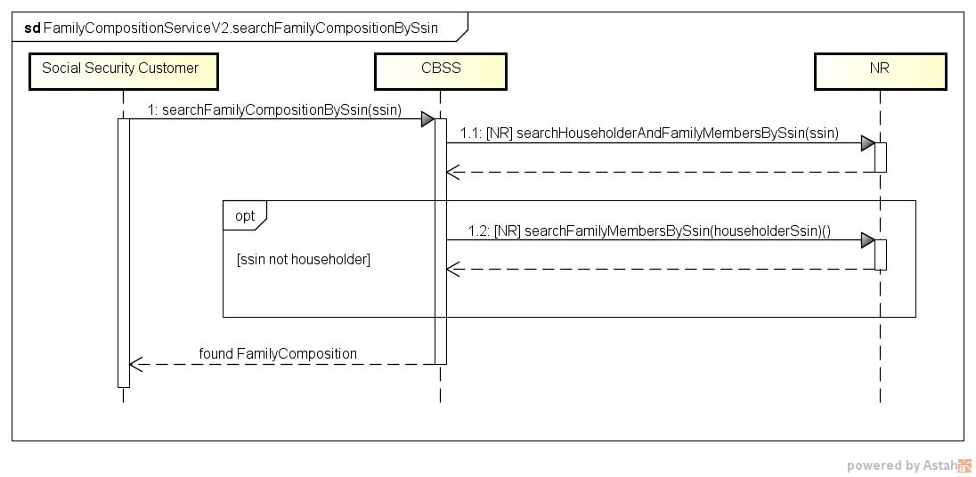

searchFamilyCompositionHistoryBySsin
Functionaliteit: de inhoud van de historiek van een gezinssamenstelling raadplegen op basis van een INSZ-nummer.
Eerst worden alle gezinshoofden voor het meegegeven INSZ opgezocht en vervolgens voor elk gezinshoofd alle gezinsleden. Enkel de leden met een periode-overlapping met het meegegeven INSZ worden meegedeeld.

Activiteitendiagram
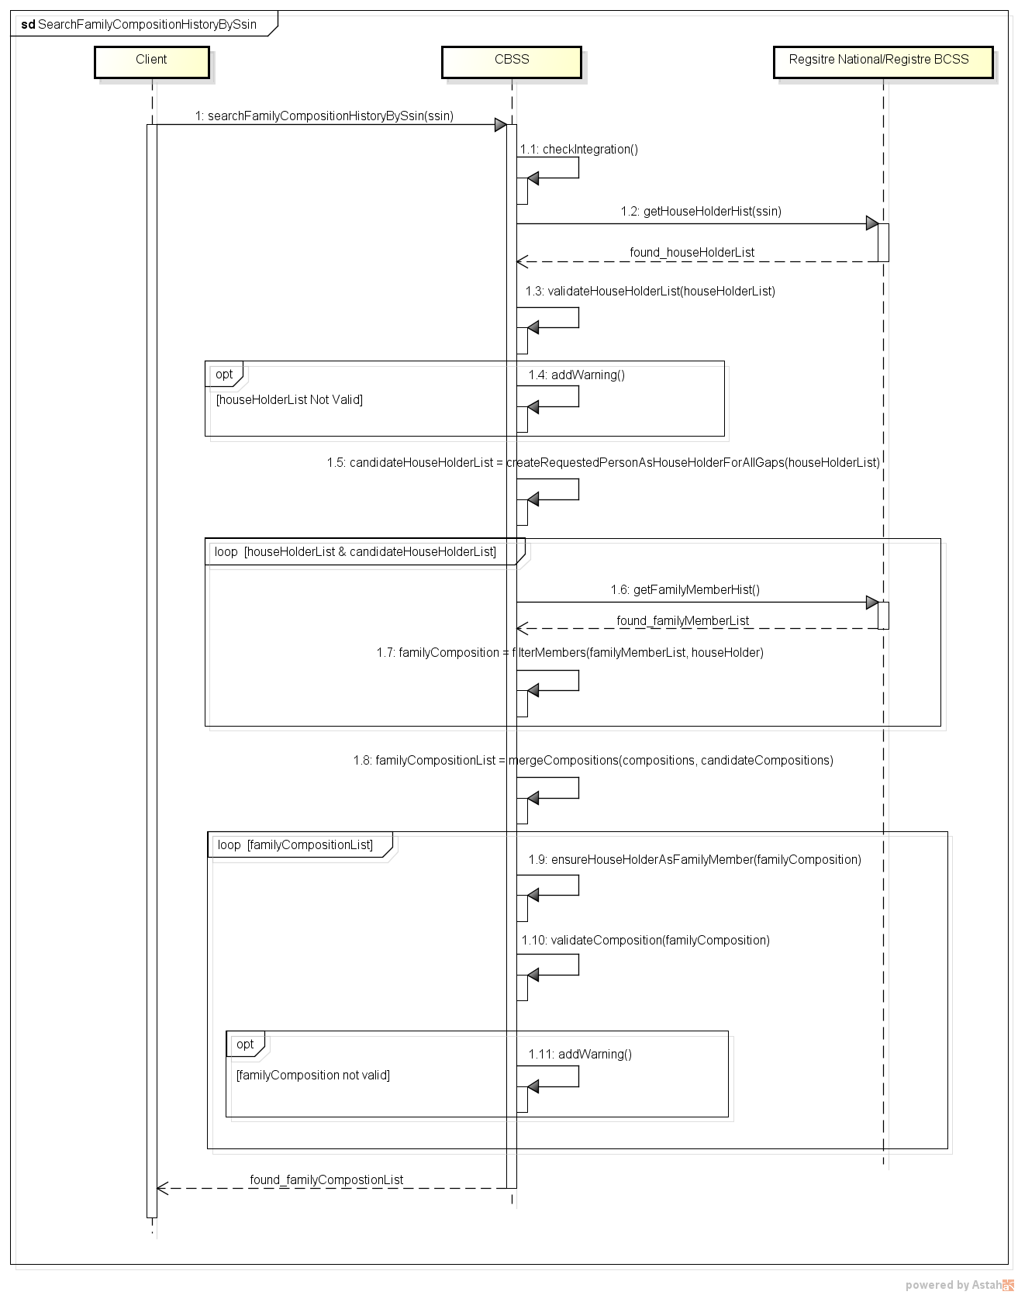

searchFamilyCompositionBySsinAndDate
Functionaliteit: de inhoud van een gezinssamenstelling raadplegen op basis van een INSZ-nummer en een welbepaalde referentiedatum.
Eerst worden alle gezinshoofden voor een meegegeven INSZ opgezocht en daarna voor de persoon die gezinshoofd was op de gevraagde datum alle gezinsleden. Enkel de leden met een periode-overlapping met het meegegeven INSZ worden meegedeeld.
Het gebruik van de bewerking searchFamilyCompositionBySsinAndDate is strikt voorbehouden voor een gegevensraadpleging in het verleden. Deze bewerking houdt de aanvraag van en de verwerking van historiekgegevens in, wat totaal overbodig is voor het verkrijgen van een actuele situatie. In geval van incoherenties in de rijksregistergegevens, is de raadpleging van de huidige situatie meer betrouwbaar. Voor een raadpleging van de actuele gegevens, moet de volgende bewerking worden gebruikt
searchFamilyCompositionBySsin.

Activiteitendiagram
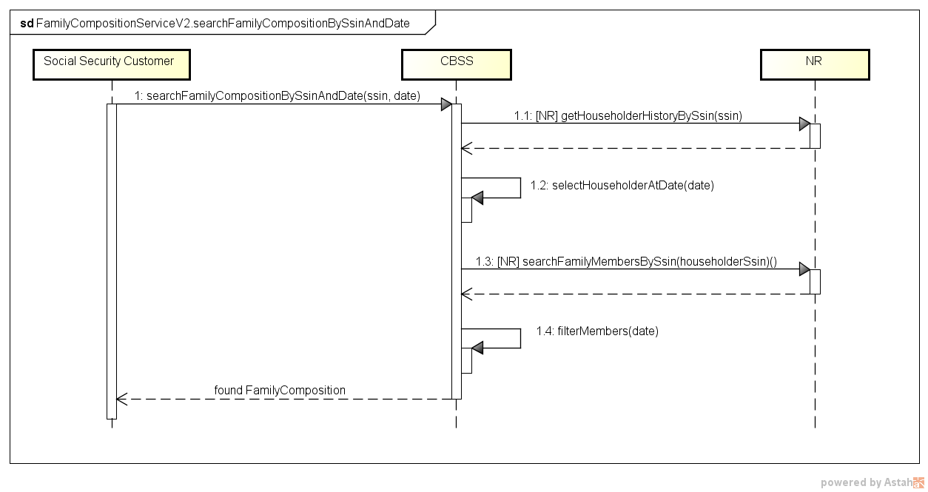

searchHouseholderBySsin

Activiteitendiagram
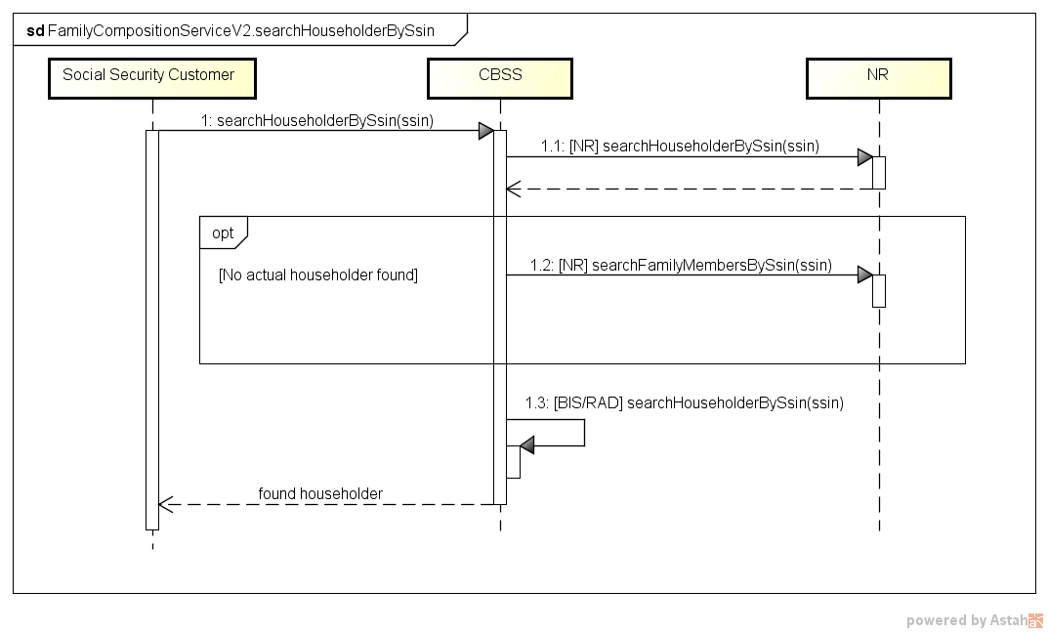

searchHouseholderHistoryBySsin

Activiteitendiagram
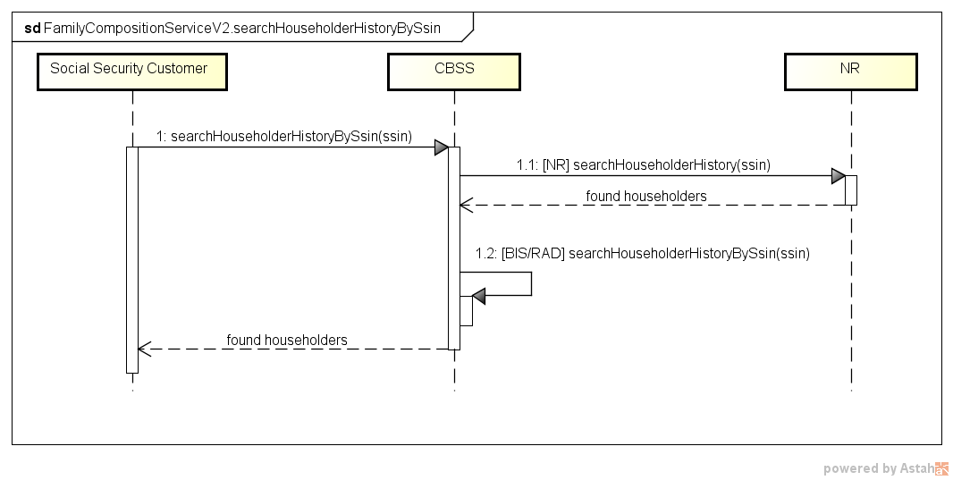

searchHouseholderBySsinAndDate

Activiteitendiagram
Zie §3.2.5.1

Stappen van de verwerking bij de KSZ
- Controle van de integriteit van de berichten (XSD-validatie)
- Veiligheidslogging
- Validatie van de zoekcriteria
- Controle van het INSZ
- Integratiecontrole
- Filtering
- Samenstelling van het resultaat

Controle van de integriteit van de berichten
Het betreft een klassieke validatie van het XML-bericht ten opzichte van het schema. Het betreft dus een validatie van de vereisten inzake type gegevens en structuur ervan.

Veiligheidslogging
Om wettelijke redenen verricht de KSZ een logging van de inkomende en uitgaande berichten om veiligheidsaudits mogelijk te maken.

Validatie van de zoekcriteria
Voor de opzoekingen op datum wordt nagegaan of de datum in het verleden ligt.

Controle van het INSZ
Een INSZ is ofwel geldig ofwel ongeldig.
- Als het ongeldig is (probleem met de syntax en/of checksum), dan wordt het bericht verworpen door de KSZ en wordt er een foutbericht teruggestuurd naar de klant met vermelding dat het INSZ ongeldig is.
- Als het INSZ geldig is, dient te worden bepaald of het tot een speciale categorie behoort. Als dit niet het geval is, kan de verwerking worden voortgezet.
Speciale categorieën:
  - Onbekend INSZ: het INSZ is niet gekend in het Rijksregister of het KSZ-register. Het bericht wordt in dat geval verworpen en er wordt een foutbericht teruggestuurd naar de klant met vermelding dat het gebruikte INSZ niet gekend is.
  - Geannuleerd INSZ: het INSZ werd geannuleerd door het Rijkregister. De verwerking wordt dan niet voortgezet en de klant krijgt in het antwoord een aanduiding dat het INSZ geannuleerd werd.
  - Vervangen INSZ: de verwerking wordt voortgezet met het nieuwe INSZ en de klant krijgt in het antwoord een aanduiding dat het INSZ vervangen werd. In het antwoord wordt ook het nieuwe INSZ vermeld, alsook het resultaat van de verwerking.
Het is mogelijk dat een INSZ nog niet vervangen werd bij de leverancier, terwijl het wel al vervangen werd bij de authentieke bron. In dat geval wordt de klant verzocht zijn request in de loop van de volgende dagen opnieuw in te dienen zodat de vervanging zich binnen het netwerk kan verspreiden.

Integratiecontrole
Aangezien de raadpleging betrekking heeft op personen en de identificatie van personen aan de hand van hun INSZ gebeurt, zal de KSZ een integratiecontrole verrichten. Het doel van deze integratiecontrole is dubbel:
- Nagaan of de partner de persoon kent en dus gemachtigd is om de gevraagde gegevens te raadplegen.
- Nagaan of de gegevensleverancier de persoon kent. Hierdoor wordt vermeden dat de gegevensleverancier bevraagd wordt voor personen die hij niet kent.

Filtering
Enkel de gemachtigde persoonsgegevens worden meegestuurd.

Samenstelling van het resultaat
De gedetailleerde samenstelling van het resultaat staat in §9.1.

Berekening van de periodes
- Voor elk gezinslid wordt de periode uit het IT 140 van zijn gezinshoofd genomen.
- Indien de gevraagde persoon gezinshoofd is, wordt de periode berekend op basis van zijn gezinsleden in het IT 140.
De periodes van de gezinshoofden van de gevraagde persoon zijn niet beschikbaar en ze zijn niet relevant. Wat telt voor de gevraagde persoon, is de periode waarin ze deel uitmaakte van het gezin.

Berekening van de periodes: voorbeeld
INSZ A
- IT 140
  - B 2 (echtgenoot) 2008 – …
  - E 3 (zoon/dochter) 2009 – …
  - E 3 (zoon/dochter) 2011 – 2015
  - B 12 (niet-verwant) 2006 – 2008
  - A 1 (alleenstaande) 2005 – 2006
- IT 141
  - P 3 (zoon/dochter) 1982 – 2006
INSZ P
- IT 140
  - X 3 (zoon/dochter) 2014 – …
  - S 2 (echtgenoot) 2012 – …
  - M 2 (echtgenoot) 1980 – 2010
  - A 3 (zoon/dochter) 1982 – 2006
  - F 3 (zoon/dochter) 1980 – 2002
Resultaat:
- familyComposition
  - familyMember: A 1 (gezinshoofd) 2006 – …
  - familyMember: B 2 (echtgenoot) 2008 – …
  - familyMember: E 3 (zoon/dochter) 2009 – …
  - familyMember: E 3 (zoon/dochter) 2011 – 2015
  - familyMember: B 12 (niet-verwant) 2006 – 2008
- familyComposition
  - familyMember: A 1 (gezinshoofd) 2005 – 2006
- familyComposition
  - familyMember: P 1 (gezinshoofd) /
  - familyMember: M 2 (echtgenoot) 1980 – 2010
  - familyMember: A 3 (zoon/dochter) 1982 – 2006
  - familyMember: F 3 (zoon/dochter) 1980 – 2002

Protocol van de dienst
De communicatie vindt plaats binnen een beveiligde omgeving aan de hand van SOAP-berichten. Meer informatie over de dienstgeoriënteerde architectuur is te vinden in [3]. De partners die nog geen toegang hebben tot de SOA-infrastructuur van de KSZ vinden in [4] een lijst van de verschillende stappen om toegang te krijgen en deze toegang te testen.
Toepassingsprotocol | HTTPS 2ways TLS, SOAP 1.1
Naam van de dienst | FamilyCompositionService
WSDL van de dienst | FamilyCompositionServiceV2.wsdl  http://kszbcss.fgov.be/intf/registries/FamilyCompositionService/v2/consult
Acties | searchFamilyCompositionBySsin  searchFamilyCompositionHistoryBySsin  searchFamilyCompositionBySsinAndDate  searchHouseholderBySsin  searchHouseholderHistoryBySsin  searchHouseholderBySsinAndDate
Berichten | searchFamilyCompositionBySsinRequest  searchFamilyCompositionBySsinResponse  searchFamilyCompositionBySsinFault  searchFamilyCompositionHistoryBySsinRequest  searchFamilyCompositionHistoryBySsinResponse  searchFamilyCompositionHistoryBySsinFault  searchFamilyCompositionBySsinAndDateRequest  searchFamilyCompositionBySsinAndDateResponse  searchFamilyCompositionBySsinAndDateFault  searchHouseholderBySsinRequest  searchHouseholderBySsinResponse  searchHouseholderBySsinFault  searchHouseholderHistoryBySsinRequest  searchHouseholderHistoryBySsinResponse  searchHouseholderHistoryBySsinFault  searchHouseholderBySsinAndDateRequest  searchHouseholderBySsinAndDateResponse  searchHouseholderBySsinAndDateFault
Omgeving, host en port | Dev | b2b-test.ksz-bcss.fgov.be:4520
 | Acc | b2b-acpt.ksz-bcss.fgov.be:4520
 | Prod | b2b.ksz-bcss.fgov.be:4520
URI | /FamilyCompositionService/v2/consult

Beschrijving van de uitgewisselde berichten

Gemeenschappelijk gedeelte van de verschillende acties

Identificatie van de klant [informationCustomer]
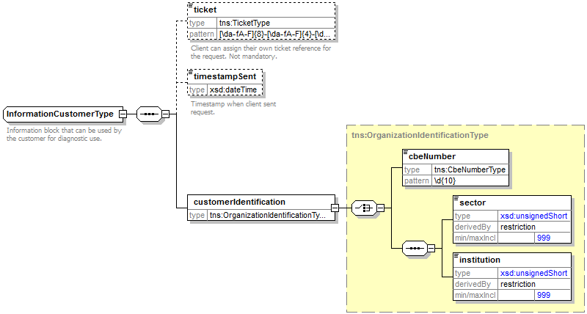
Het element informationCustomer wordt geleverd door de klant om zich te identificeren op businessniveau door zijn identificatie mee te delen hetzij op het niveau van het netwerk van de sociale zekerheid, hetzij op ondernemingsniveau. Het kan business- en tijdsreferenties omvatten.
De identificatie van de instelling is gedefinieerd in een bericht:
- hetzij op basis van de combinatie sector / instelling voor de instellingen van sociale zekerheid
- hetzij op basis van het KBO-nummer voor de instellingen die geen deel uitmaken van het netwerk van de sociale zekerheid of voor de instellingen voor dewelke het KBO-nummer een toegevoegde waarde biedt ten opzichte van het gebruik van sector / instelling

Identificatie van de KSZ [informationCBSS]
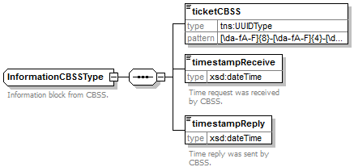
Het element informationCBSS, dat facultatief is in de request, wordt ingevuld door de KSZ en geeft informatie die nodig is voor de logging en de support.

Wettelijke context van de oproep [legalContext]
Het element legalContext laat toe het wettelijke kader van het verzoek te definiëren.

Status van het antwoord [status]
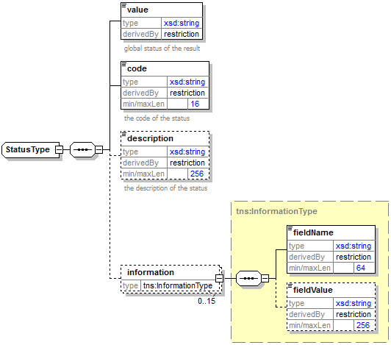
Het element status is aanwezig in elk antwoord van de KSZ en geeft de globale status van de verwerking van de request weer. Het bestaat uit de volgende elementen:
- value : algemene aanduiding van de status van het antwoord. 3 mogelijke waarden:
Waarde | Beschrijving
DATA_FOUND | Verwerking geslaagd.
NO_DATA_FOUND | Verwerking geslaagd maar geen gegevens gevonden.
NO_RESULT | De verwerking is niet succesvol verlopen. Er werd geen informatie ontvangen.

- code : preciezer dan het element value, dit veld bevat een businesscode eigen aan de dienst.
- description : dit element geeft uitleg over de betekenis van het veld code.
- information : dit element wordt ingevuld wanneer verdere informatie moet worden toegevoegd aan de status om een bijkomende toelichting te krijgen

INSZ met ‘geannuleerde’ of ‘vervangt’ status [ssin]
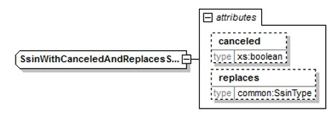
Het element ssin is aanwezig in het antwoord van de KSZ en geeft het INSZ terug waarmee de aanvraag gebeurd is samen met status informatie over dit INSZ in de attributen:
Attribuut | Beschrijving
canceled | Als dit aanwezig is en op true staat is het INSZ geannuleerd en niet bruikbaar.
replaces | Als dit aanwezig is, is het INSZ vervangen. Het originele INSZ wordt teruggegeven in dit attribuut en het nieuwe INSZ zit in het element zelf.

Gezinssamenstelling [familyComposition]
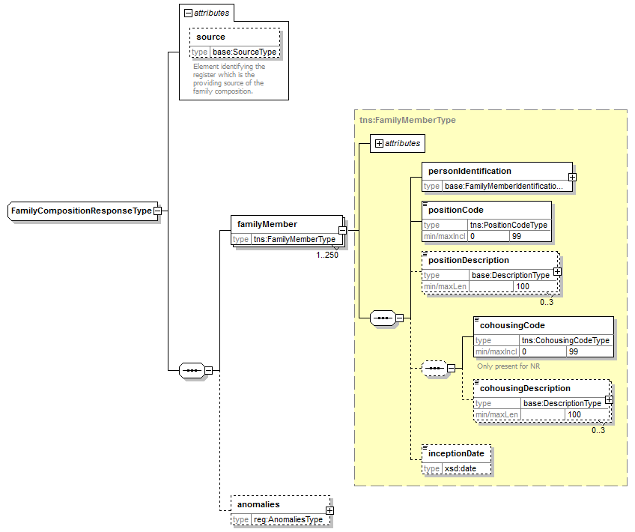
Element |  | Beschrijving
source |  | Gegevensbron. Steeds Rijksregister.
familyMember |  | Details van een gezinslid
 | source | Gegevensbron. Steeds Rijksregister.
 | personIdentification | Persoonsgegevens van het gezinslid
 | positionCode | De positie ten opzichte van het gezinshoofd.
 | positionDescription | Beschrijving van de code positie
 | cohousingCode | Code met betrekking tot het begrip collectieve woning
 | cohousingDescription | Beschrijving van de code collectieve woning
 | inceptionDate | Datum van intrede van het lid in het gezin
anomalies |  | Waarschuwingen voor incoherenties in de gezinssamenstelling

Identificatie van een gezinslid [FamilyMemberIdentificationType]
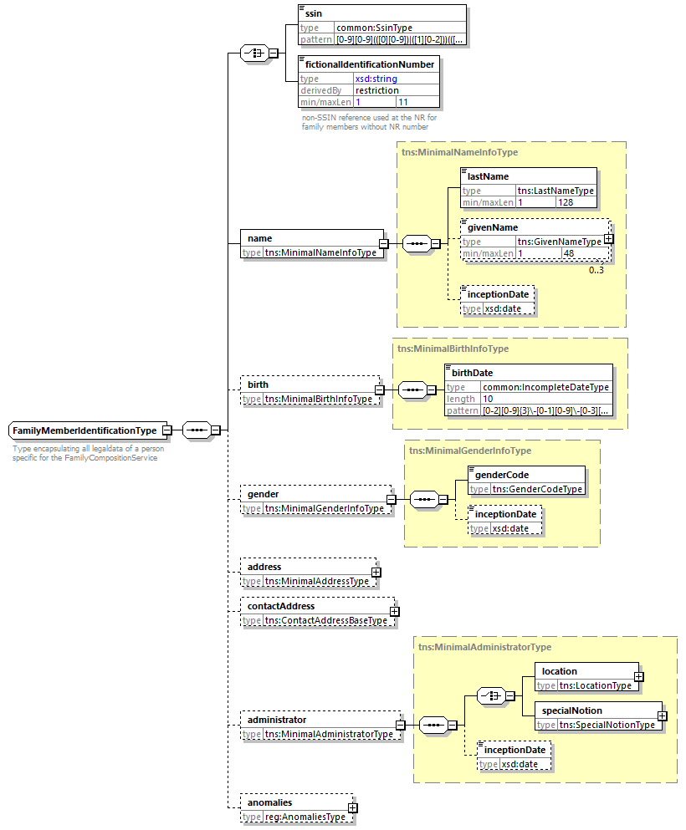

Element |  | Beschrijving
ssin |  | INSZ-nummer van het gezinslid
fictionalIdentificationNumber |  | Fictief identificatienummer, dat door het Rijksregister wordt gebruikt voor een gezinslid zonder geldig INSZ
name |  | De naam
 | lastName | naam
 | givenName | 1 tot 3 voornamen
 | inceptionDate | Aanvangsdatum
birth |  | Informatie over de geboorte
 | birthDate | geboortedatum
gender |  | Informatie over het geslacht
 | genderCode | Het geslacht
 | inceptionDate | Aanvangsdatum
address |  | Het adres van de persoon. Enkel aanwezig voor het gezinshoofd in de huidige situatie.
contactAddress |  | Contactadres van de persoon. Niet aanwezig voor de personen in het Rijksregister.
administrator |  | Informatie over de gegevensbeheerder. Enkel aanwezig voor het gezinshoofd in de huidige situatie
 | location | Gegevensbeheerder (gemeente of land)
 | specialNotion | Specifieke NIS-code. In principe is dit niet mogelijk voor een gezinslid
 | inceptionDate | Aanvangsdatum
anomalies |  | Incoherenties in de persoonsgegevens

Adres [address]
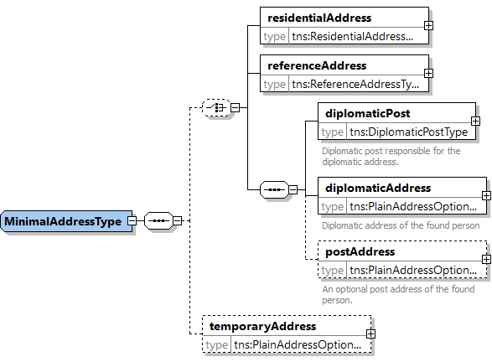
Element | Beschrijving
residentialAddress | Verblijfsadres in België
referenceAddress | Referentie adres (binnenlands)
diplomaticPost | Niet aanwezig
diplomaticAddress | Niet aanwezig
postAddress | Niet aanwezig
temporaryAddress | Niet aanwezig

Verblijfsadres [residentialAddress]

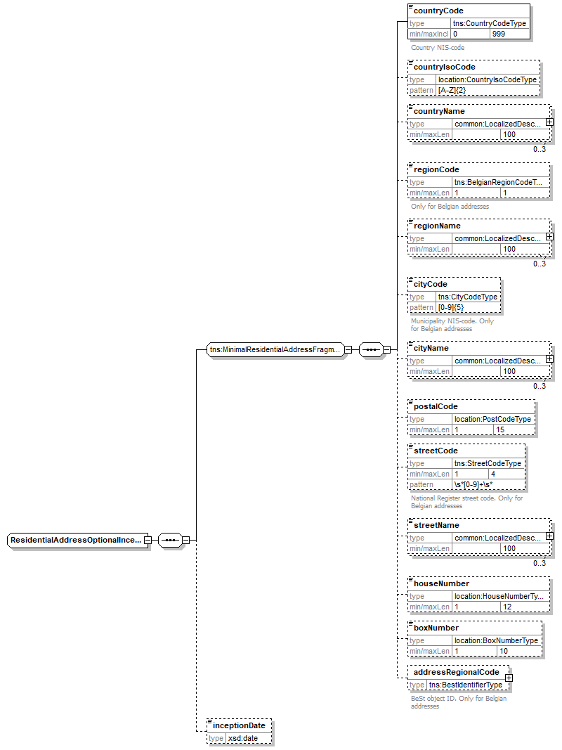
De mogelijke velden zijn verschillend voor een Belgisch en een buitenlands adres. Voor een Belgisch adres mogen alle velden worden ingevuld. Wat het adres in het buitenland betreft, worden de velden die van toepassing zijn aangevinkt in de kolom “Buitenland”.
Element | Beschrijving | Buitenland | Belgisch “oud” | Belgisch « BeSt »
countryCode | De landcode van het land (NIS-code) | ✓ | 150 | 150
countryIsoCode | De ISO-code van het land in de vorm van een 2-lettercode (ISO 3166 alpha-2) | ✓ | ✓ | ✓
countryName | De naam van het land | ✓ | ✓ | ✓
regionCode | De regiocode van de regio |  |  | ✓
regionName | De benaming van de regio |  |  | ✓
cityCode | Gemeentecode (NIS-code) |  | ✓ | ✓
cityName | Naam van de gemeente | ✓ | ✓
postalCode | Postcode van de gemeente | ✓ | ✓
streetCode | Straatcode toegekend door het Rijksregister |  | ✓
streetName | Naam van de straat | ✓ | ✓ | ✓
HouseNumber | Huisnummer | ✓ | ✓ | ✓
boxNumber | Busnummer | ✓ | ✓ | ✓
addressRegionalCode | Een uniek identificatienummer van het adres binnen de regionale authentieke bron |  |  | ✓
inceptionDate | Aanvangsdatum van het gegeven | ✓ | ✓ | ✓

ReferentieAdres [referenceAddress]
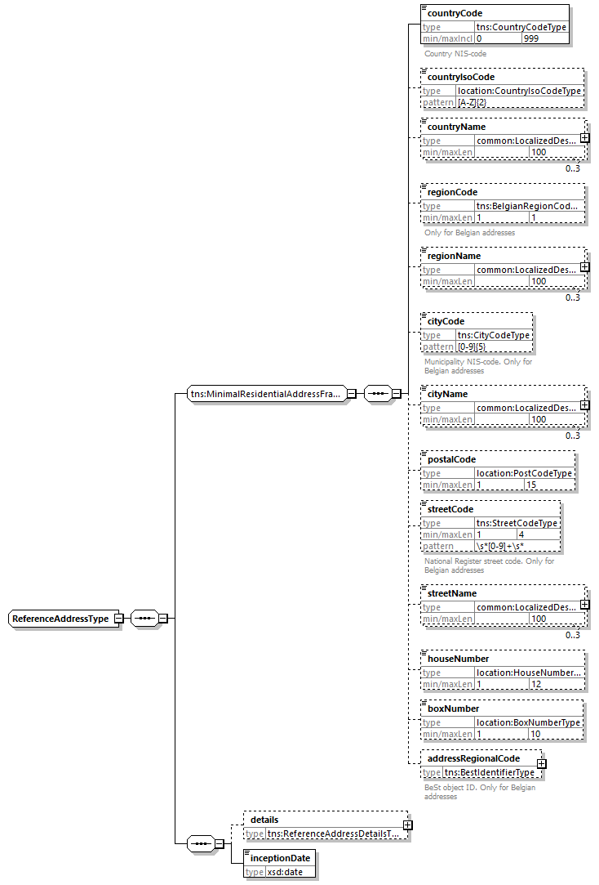
Element | Beschrijving
countryCode | De landcode van het land (NIS-code)
countryIsoCode | De 2-letterige ISO code van het land (ISO 3166 alpha-2)
countryName | De naam van het land
regionCode | De regiocode van het het gewest
regionName | De benaming van het gewest
cityCode | Gemeentecode (NIS-code)
cityName | Gemeentenaam
postalCode | Postcode van de gemeente
streetCode | Straatcode toegekend door het Rijksregister
streetName | Straatnaam
houseNumber | Huisnummer
boxNumber | Busnummer
addressRegionalCode | Een uniek identificatienummer van het adres binnen de regionale authentieke bron
details | Details over het referentieadres
inceptionDate | Ingangsdatum van het gegeven

Referentieadres details [referenceAddressDetails]
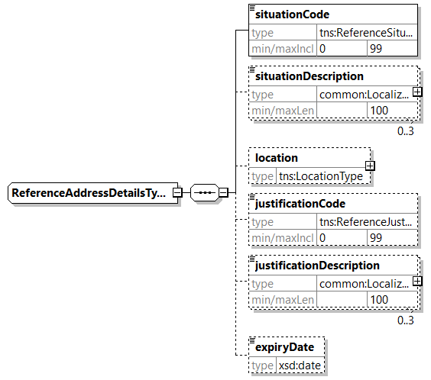
element | beschrijving
situationCode | Code die overeenkomt met een categorie/situatie waarin de persoon zich bevindt.
situationDescription | Een categorie/situatie waarin de persoon zich bevindt.
location | De betrokken gemeente.
justificationCode | Code die overeenkomt met een reden waarom een referentieadres werd toegekend
justificationDescription | Beschrijving van de reden waarom een referentieadres werd toegekend
expiryDate | De verwachte einddatum van de status van het referentieadres.

Historiek gezinssamenstelling [familyComposition]
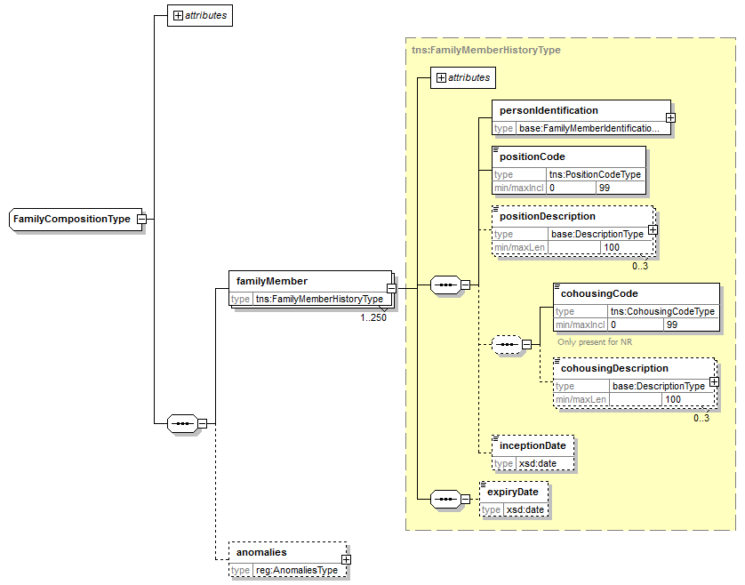
Element |  | Beschrijving
source |  | Gegevensbron. Steeds Rijksregister.
familyMember |  | Details van een gezinslid
 | (Alle velden) | Zie §5.1.6
 | expiryDate | Einddatum voor het lid in het gezin
anomalies |  | Waarschuwingen voor incoherenties in de gegevens met betrekking tot de gezinssamenstelling

Gezinshoofd [householder]
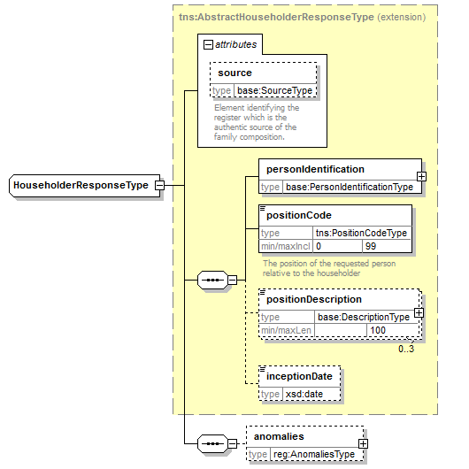
Element | Beschrijving
Bron | Gegevensbron. Steeds Rijksregister.
ssin | INSZ-nummer van het gezinshoofd
personIdentification | Persoonsgegevens van het gezinshoofd
positionCode | De positie van de betrokken persoon ten opzichte van het gezinshoofd
positionDescription | Beschrijving van de code positie
inceptionDate | Datum van intrede van de persoon in het gezin van het gezinshoofd
anomalies | Waarschuwingen voor incoherenties in de gegevens over de gezinshoofden

Historiek gezinshoofd [householder]
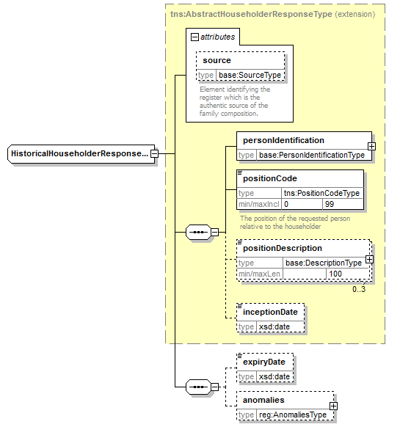
Element | Beschrijving
(Andere velden) | Zie §5.1.11
expiryDate | Einddatum in de samenstelling van het gezinshoofd

Identificatie van een gezinshoofd [PersonIdentificationType]
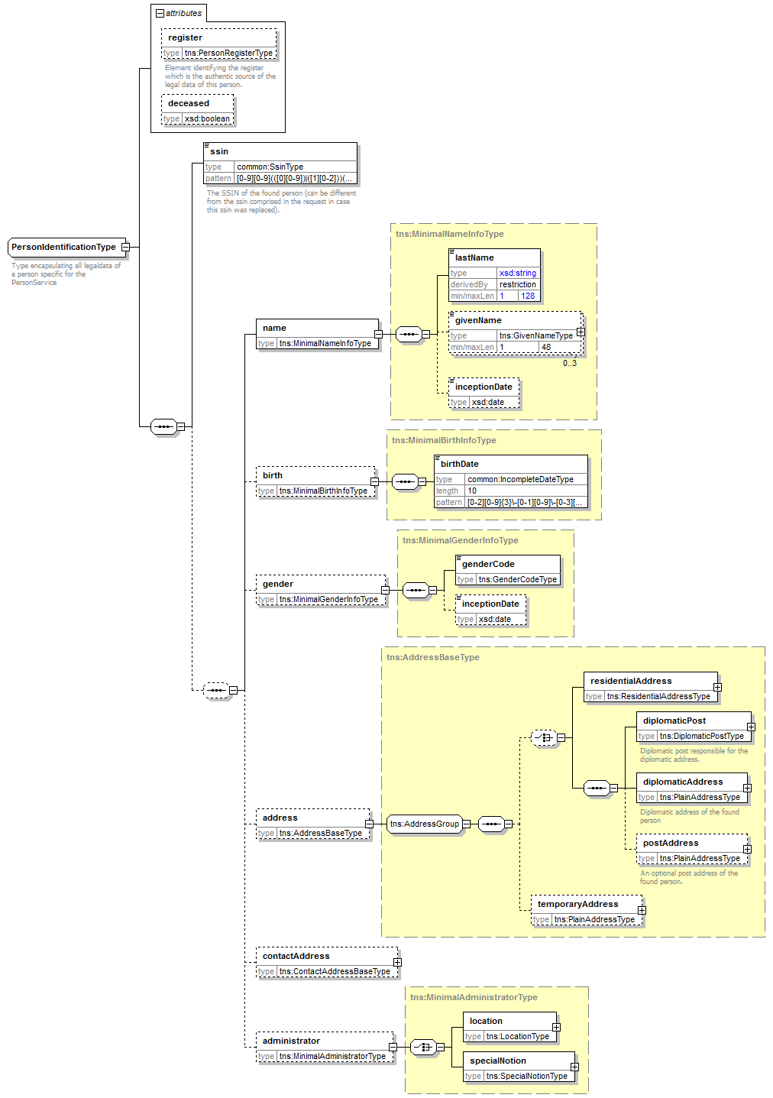
Element |  | Beschrijving
ssin |  | INSZ-nummer van het gezinshoofd
name |  | De naam
 | lastName | naam
 | givenName | 1 tot 3 voornamen
 | inceptionDate | Aanvangsdatum
birth |  | Informatie over de geboorte
 | birthDate | geboortedatum
gender |  | Informatie over het geslacht
 | genderCode | Het geslacht
 | inceptionDate | Aanvangsdatum
address |  | Niet aanwezig
contactAddress |  | Niet aanwezig
administrator |  | Niet aanwezig

Anomalieën [anomalies]
Zie [6]

searchFamilyCompositionBySsin

Request
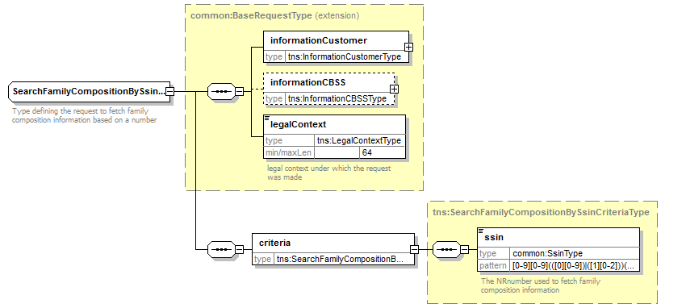

Element |  | Beschrijving
informationCustomer |  | Informatie over de aanvrager, zie §5.1.1
informationCBSS |  | Niet invullen
legalContext |  | Wettelijk kader, zie §5.1.3
criteria |  | Specifieke informatie met betrekking tot het opzoekingscriterium
 | ssin | Het INSZ waarvoor de gezinssamenstelling wordt gevraagd

Antwoord
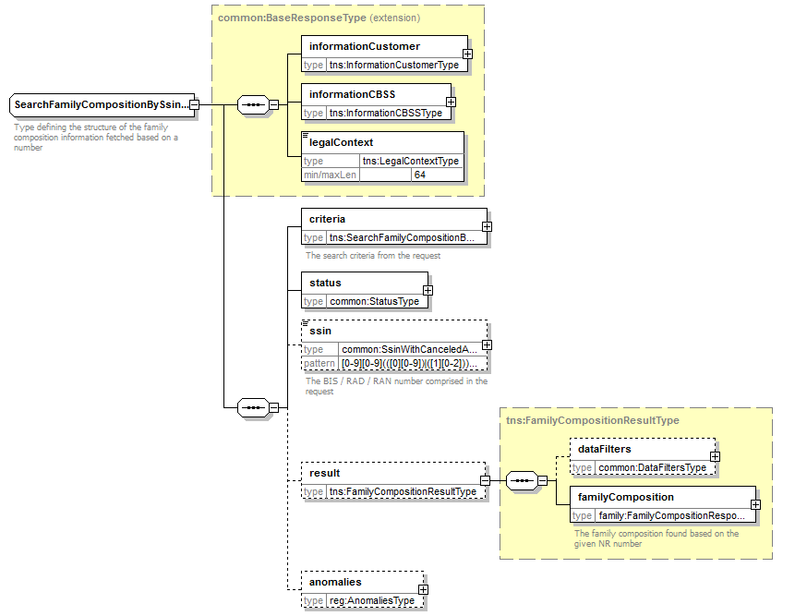

Element |  | Beschrijving
informationCustomer |  | Overgenomen uit de request
informationCBSS |  | Informatie van de KSZ, zie §5.1.2
legalContext |  | Overgenomen uit de request
criteria |  | Overgenomen uit de request
status |  | Status van het antwoord, zie §5.1.4
ssin |  | Het INSZ waarvoor er is geantwoord, zie § 5.1.5
result |  | Het resultaat van de opzoeking
 | dataFilters | De toegepaste gegevensfiltering
 | familyComposition | De gevonden gezinssamenstelling, zie § 5.1.6
anomalies |  | Waarschuwingen voor incoherenties  - waardoor het niet mogelijk is om een gezinssamenstelling op te maken  - die niet ressorteren onder een specifieke samenstelling

searchFamilyCompositionHistoryBySsin

Request
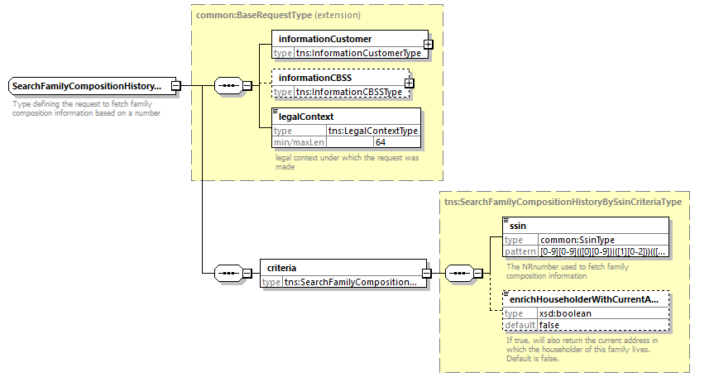

Element |  | Beschrijving
informationCustomer |  | Informatie over de aanvrager, zie §5.1.1
informationCBSS |  | Niet invullen
legalContext |  | Wettelijk kader, zie §5.1.3
criteria |  | Specifieke informatie met betrekking tot het opzoekingscriterium
 | ssin | Het INSZ waarvoor de gezinssamenstelling wordt gevraagd
 | datum | Maakt het mogelijk om de gezinssamenstelling op die datum terug te vinden
 | enrichHouseholderWithCurrentAddress | Optionele vlag, die toelaat om het huidige adres te krijgen bij elk gezinshoofd. Indien niet gebruikt zullen geen adressen gegeven worden.

Antwoord
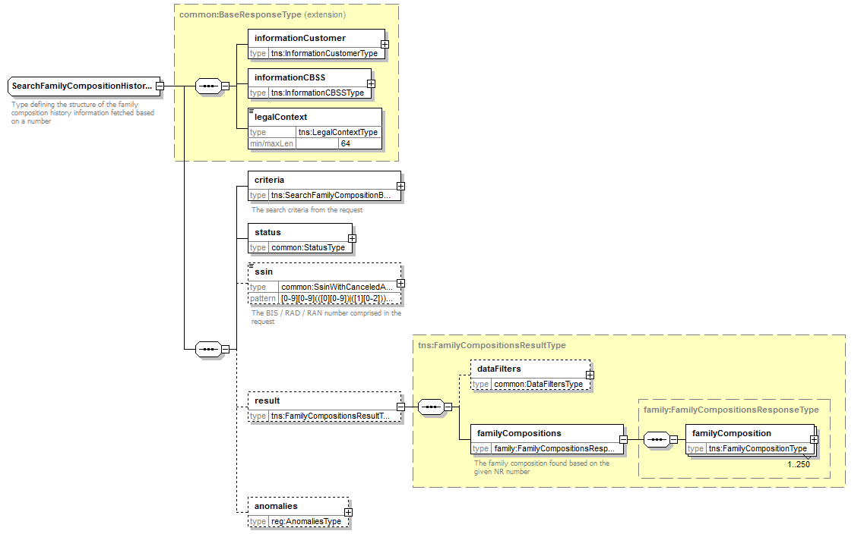

Element |  |  | Beschrijving
informationCustomer |  |  | Overgenomen uit de request
informationCBSS |  |  | Informatie van de KSZ, zie §5.1.2
legalContext |  |  | Overgenomen uit de request
criteria |  |  | Overgenomen uit de request
status |  |  | Status van het antwoord, zie §5.1.4
ssin |  |  | Het INSZ waarvoor er is geantwoord, zie § 5.1.5
result |  |  | Het resultaat van de opzoeking
 | dataFilters |  | De toegepaste gegevensfiltering
 | familyCompositions |  | De gevonden historische gezinssamenstellingen
 |  | familyComposition | Zie §5.1.7
anomalies |  |  | Waarschuwingen voor incoherenties  - waardoor het niet mogelijk is om een samenstelling op te maken  - die niet ressorteren onder een specifieke samenstelling

searchFamilyCompositionBySsinAndDate

Request

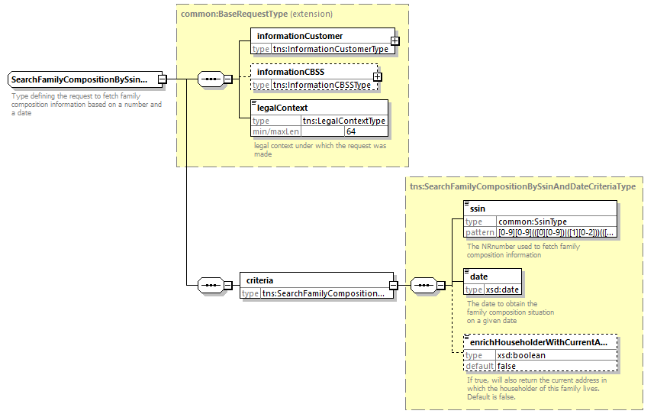
Element |  | Beschrijving
informationCustomer |  | Informatie over de aanvrager, zie §5.1.1
informationCBSS |  | Niet invullen
legalContext |  | Wettelijk kader, zie §5.1.3
criteria |  | Specifieke informatie met betrekking tot het opzoekingscriterium
 | ssin | Het INSZ waarvoor de gezinssamenstelling wordt gevraagd
 | datum | Maakt het mogelijk om de gezinssamenstelling op die datum terug te vinden
 | enrichHouseholderWithCurrentAddress | Optionele vlag, die toelaat om het huidige adres te krijgen bij het gezinshoofd. Indien niet gebruikt zal geen adres gegeven worden.

Antwoord
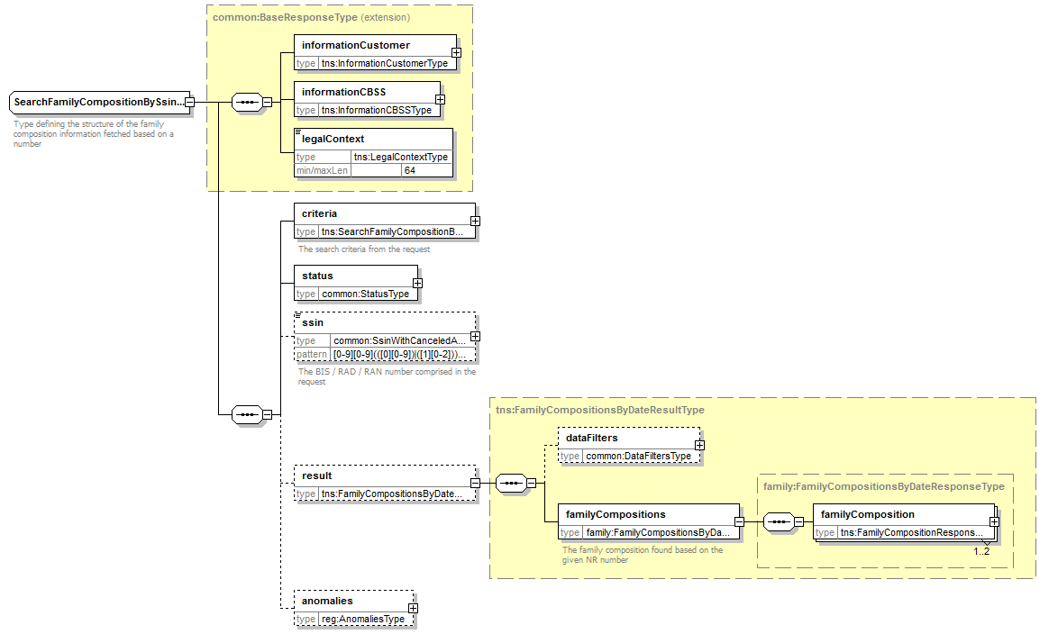

Element |  |  | Beschrijving
informationCustomer |  |  | Overgenomen uit de request
informationCBSS |  |  | Informatie van de KSZ, zie §5.1.2
legalContext |  |  | Overgenomen uit de request
criteria |  |  | Overgenomen uit de request
status |  |  | Status van het antwoord, zie §5.1.4
ssin |  |  | Het INSZ waarvoor er is geantwoord, zie § 5.1.5
result |  |  | Het resultaat van de opzoeking
 | dataFilters |  | De toegepaste gegevensfiltering
 | familyCompositions |  | De gevonden gezinssamenstellingen (1, max. 2 indien ondersteund door de KSZ-registers)
 |  | familyComposition | Zie §5.1.6
anomalies |  |  | Waarschuwingen voor incoherenties  - waardoor het niet mogelijk is om een samenstelling op te maken  - die niet ressorteren onder een specifieke samenstelling

searchHouseholderBySsin

Request
Idem §5.2.1

Antwoord
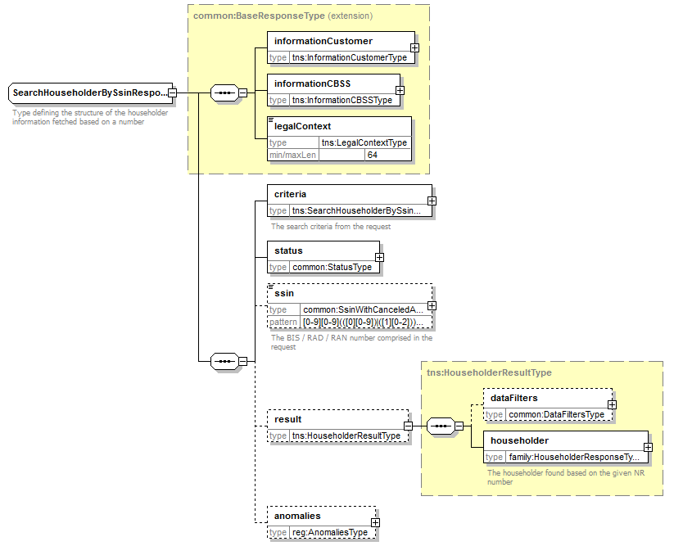
Element |  | Beschrijving
informationCustomer |  | Overgenomen uit de request
informationCBSS |  | Informatie van de KSZ, zie §5.1.2
legalContext |  | Overgenomen uit de request
criteria |  | Overgenomen uit de request
status |  | Status van het antwoord, zie §5.1.4
ssin |  | Het INSZ waarvoor er is geantwoord, zie § 5.1.5
result |  | Het resultaat van de opzoeking
 | dataFilters | De toegepaste gegevensfiltering
 | householder | Het gevonden gezinshoofd, zie §5.1.8
anomalies |  | Waarschuwingen voor incoherenties  - waardoor het gezinshoofd niet kan worden bepaald  - die niet behoren tot een bepaald gezinshoofd

searchHouseholderHistoryBySsin

Request
Idem §5.2.1

Antwoord
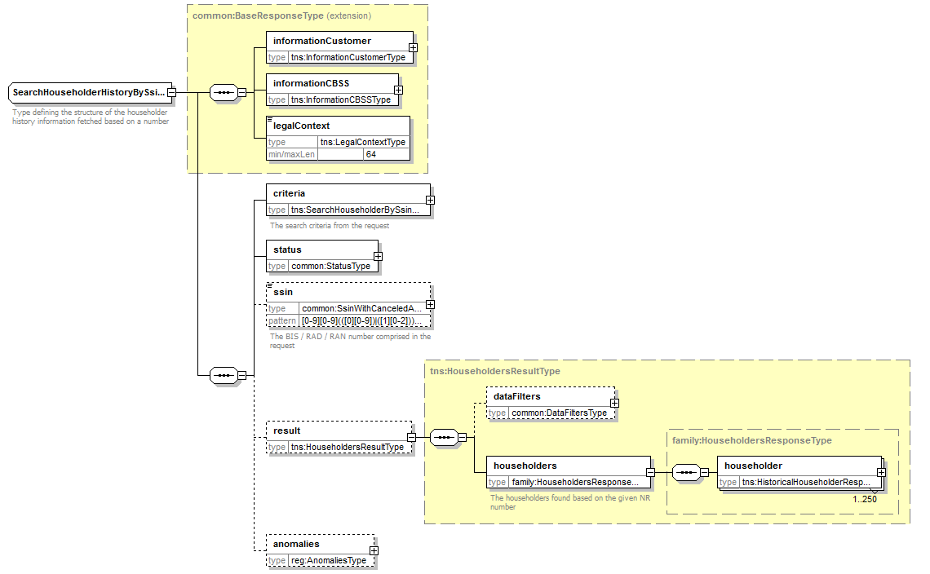
Elemenet |  |  | Beschrijving
informationCustomer |  |  | Overgenomen uit de request
informationCBSS |  |  | Informatie van de KSZ, zie §5.1.2
legalContext |  |  | Overgenomen uit de request
criteria |  |  | Overgenomen uit de request
status |  |  | Status van het antwoord, zie §5.1.4
ssin |  |  | Het INSZ waarvoor er is geantwoord, zie §5.1.5
result |  |  | Het resultaat van de opzoeking
 | dataFilters |  | De toegepaste gegevensfiltering
 | householders |  | De gevonden historiek gezinssamenstellingen
 |  | householder | Zie §5.1.9
anomalies |  |  | Waarschuwingen voor incoherenties  - waardoor het gezinshoofd niet kan worden bepaald  - die niet behoren tot een bepaald gezinshoofd

searchHouseholderBySsinAndDate

Request
Idem §5.4.1

Antwoord
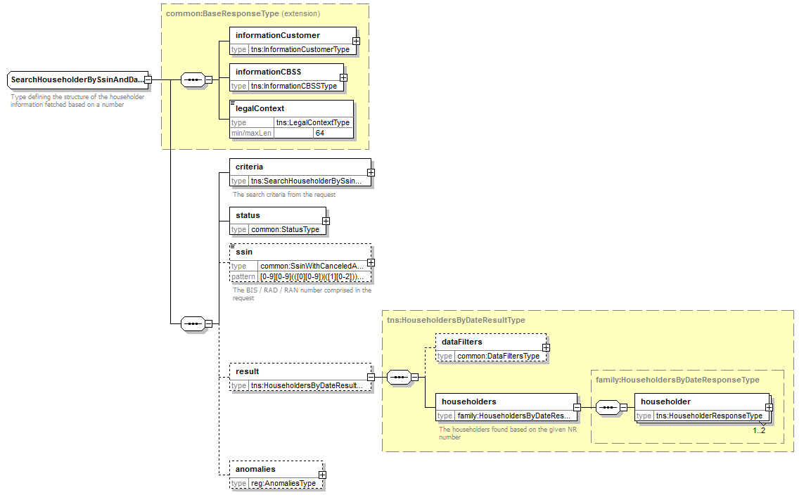
Element |  |  | Beschrijving
informationCustomer |  |  | Overgenomen uit de request
informationCBSS |  |  | Informatie van de KSZ, zie §5.1.2
legalContext |  |  | Overgenomen uit de request
criteria |  |  | Overgenomen uit de request
status |  |  | Status van het antwoord, zie §5.1.4
ssin |  |  | Het INSZ waarvoor er is geantwoord, zie §5.1.5
result |  |  | Het resultaat van de opzoeking
 | dataFilters |  | De toegepaste gegevensfiltering
 | householders |  | De gevonden gezinshoofden (1, max 2 wanneer ondersteund door de KSZ-registers)
 |  | householder | Zie §5.1.8
anomalies |  |  | Waarschuwingen voor incoherenties  - waardoor het gezinshoofd niet kan worden bepaald  - die niet behoren tot een bepaald gezinshoofd

Fault
Zie [6].

Codes status van de KSZ-antwoorden
Zie [6].

Codelijsten
Zie [5].

Beschikbaarheid en performantie
De KSZ geeft geen SLA over de antwoordtijden en de beschikbaarheid van webservices, omdat ze afhankelijk zijn van de authentieke bron waarover de KSZ geen bevoegdheid noch verantwoordelijkheid heeft.
Voor het deel van verwerking dat intern bij de KSZ plaatsvindt, garandeert de KSZ een beschikbaarheid van 98% en de volgende verwerkingstijden:
90% < 1 seconde en 95% < 2 seconden
Bij onderbrekingen in de dienstverlening of in de verbinding met het Rijkregister, is het mogelijk dat wij de verbindingen voortijdig afbreken om te vermijden dat de systemen overbelast worden. Wanneer dit gebeurt, wordt eenzelfde fout teruggegeven als wanneer het Rijksregister effectief werd bereikt maar er een technisch probleem (bijv. timeout) optreedt.

Bij problemen
Neem contact op met de service desk
- telefonisch op het nummer 02-741 84 00 tussen 8u en 16u30 op werkdagen,
- via mail aan: servicedesk@ksz-bcss.fgov.be,
en vermeld daarbij de volgende informatie:
- soap-berichten (request en antwoord)
- ticket van het bericht, met name het KSZ-ticket (bij voorkeur) of de referentie van het bericht dat door de klant zelf werd toegevoegd
- datum en uur van de raadpleging
- URL of naam van de dienst alsook omgeving.
- De omgeving waarin het probleem zich voordoet (acceptatie of productie)
Meer informatie over de service desk vindt u op onze website.

Best practices

Validatie aan de hand van een WSDL/XSD
Wij raden onze partners aan om een validatie te verrichten aan de hand van het WSDL-bestand van de requests die zij ons doorsturen. Als de request immers niet geldig is, zal ze worden geweigerd.

Formaat van de datums
Het wordt ten zeerste aangeraden om geen tijdzone of "Z" toe te voegen in datumvelden van het formaat “xs:date”. In sommige contexten/programma's kan het zijn dat de tijdzone meetelt, met een andere datum dan de bedoelde datum als resultaat.

Voorbeeldberichten

searchFamilyCompositionBySsin

Request
<soapenv:Envelope xmlns:soapenv="http://schemas.xmlsoap.org/soap/envelope/" xmlns:v2="http://kszbcss.fgov.be/intf/registries/FamilyCompositionService/v2">
<soapenv:Header/>
<soapenv:Body>
<v2:searchFamilyCompositionBySsinRequest>
<informationCustomer>
<customerIdentification>
<cbeNumber>********31</cbeNumber>
</customerIdentification>
</informationCustomer>
<legalContext>***************</legalContext>
<criteria>
<ssin>*********87</ssin>
</criteria>
</v2:searchFamilyCompositionBySsinRequest>
</soapenv:Body>
</soapenv:Envelope>

Response
<soap:Envelope xmlns:soap="http://schemas.xmlsoap.org/soap/envelope/">
<soap:Header/>
<soap:Body>
<external:searchFamilyCompositionBySsinResponse xmlns:external="http://kszbcss.fgov.be/intf/registries/FamilyCompositionService/v2">
<informationCustomer>
<customerIdentification>
<cbeNumber>********31</cbeNumber>
</customerIdentification>
</informationCustomer>
<informationCBSS>
<ticketCBSS>1d8742ac-f687-4079-b5e7-c4ed24dd2efe</ticketCBSS>
<timestampReceive>2018-10-24T12:50:09.217Z</timestampReceive>
<timestampReply>2018-10-24T12:50:12.042Z</timestampReply>
</informationCBSS>
<legalContext>***************</legalContext>
<criteria>
<ssin>*********87</ssin>
</criteria>
<status>
<value>DATA_FOUND</value>
<code>MSG00000</code>
<description>Treatment successful</description>
</status>
<ssin>*********87</ssin>
<result>
<familyComposition source="NR">
<familyMembers>
<familyMember source="NR">
<personIdentification>
<ssin>*********87</ssin>
<name>
<lastName>********</lastName>
<givenName sequence="1">****</givenName>
<inceptionDate>****-**-**</inceptionDate>
</name>
<birth>
<birthDate>****-**-**</birthDate>
</birth>
<gender>
<genderCode>F</genderCode>
</gender>
<address>
<residentialAddress>
<countryCode>150</countryCode>
<countryIsoCode>BE</countryIsoCode>
<countryName language="FR">Belgique</countryName>
<countryName language="NL">België</countryName>
<countryName language="DE">Belgien</countryName>
<cityCode>23027</cityCode>
<cityName language="NL">Halle</cityName>
<postalCode>1500</postalCode>
<streetCode>****</streetCode>
<streetName language="NL">**************</streetName>
<houseNumber>*</houseNumber>
<boxNumber>****</boxNumber>
<inceptionDate>****-**-**</inceptionDate>
</residentialAddress>
</address>
<administrator>
<location>
<countryCode>150</countryCode>
<countryIsoCode>BE</countryIsoCode>
<countryName language="FR">Belgique</countryName>
<countryName language="NL">België</countryName>
<countryName language="DE">Belgien</countryName>
<cityCode>23027</cityCode>
<cityName language="NL">Halle</cityName>
</location>
<inceptionDate>****-**-**</inceptionDate>
</administrator>
</personIdentification>
<positionCode>1</positionCode>
<positionDescription language="FR">chef de ménage</positionDescription>
<positionDescription language="NL">gezinshoofd</positionDescription>
<inceptionDate>****-**-**</inceptionDate>
</familyMember>
<familyMember source="NR">
<personIdentification>
<ssin>***********56</ssin>
<name>
<lastName>************</lastName>
<givenName sequence="1">********</givenName>
</name>
<birth>
<birthDate>****-**-**</birthDate>
</birth>
<gender>
<genderCode>M</genderCode>
</gender>
</personIdentification>
<positionCode>2</positionCode>
<positionDescription language="FR">conjoint</positionDescription>
<positionDescription language="NL">echtgenoot/echtgenote</positionDescription>
<inceptionDate>****-**-**</inceptionDate>
</familyMember>
<familyMember source="NR">
<personIdentification>
<ssin>*********75</ssin>
<name>
<lastName>*************</lastName>
<givenName sequence="1">******</givenName>
</name>
<birth>
<birthDate>****-**-**</birthDate>
</birth>
<gender>
<genderCode>F</genderCode>
</gender>
</personIdentification>
<positionCode>3</positionCode>
<positionDescription language="FR">fils/fille</positionDescription>
<positionDescription language="NL">zoon/dochter</positionDescription>
<cohousingCode>0</cohousingCode>
<cohousingDescription language="FR">Ménage non logement collectif</cohousingDescription>
<cohousingDescription language="NL">Gezin niet collectief wonen</cohousingDescription>
<inceptionDate>****-**-**</inceptionDate>
</familyMember>
</familyMembers>
</familyComposition>
</result>
</external:searchFamilyCompositionBySsinResponse>
</soap:Body>
</soap:Envelope>

Fault
<soapenv:Envelope xmlns:soapenv="http://schemas.xmlsoap.org/soap/envelope/">
<soapenv:Body>
<soapenv:Fault>
<faultcode>soapenv:Server</faultcode>
<faultstring>Error in communication with the destination/supplier</faultstring>
<faultactor>http://www.ksz-bcss.fgov.be/</faultactor>
<detail>
<n1:searchFamilyCompositionBySsinFault xmlns:n1="http://kszbcss.fgov.be/intf/registries/FamilyCompositionService/v2">
<informationCustomer>
<customerIdentification>
<cbeNumber>********31</cbeNumber>
</customerIdentification>
</informationCustomer>
<informationCBSS>
<ticketCBSS>1d5ad78d-d41e-4efd-b0f9-a30cb7727eb7</ticketCBSS>
<timestampReceive>2018-11-14T07:42:41.201Z</timestampReceive>
<timestampReply>2018-11-14T07:42:41.492Z</timestampReply>
</informationCBSS>
<detail>
<severity>FATAL</severity>
<reasonCode>MSG00002</reasonCode>
<diagnostic>Error in communication with the destination/supplier</diagnostic>
<authorCode>http://www.ksz-bcss.fgov.be/</authorCode>
</detail>
</n1:searchFamilyCompositionBySsinFault>
</detail>
</soapenv:Fault>
</soapenv:Body>
</soapenv:Envelope>

searchFamilyCompositionHistoryBySsin

Request
<soapenv:Envelope xmlns:soapenv="http://schemas.xmlsoap.org/soap/envelope/" xmlns:v2="http://kszbcss.fgov.be/intf/registries/FamilyCompositionService/v2">
<soapenv:Header/>
<soapenv:Body>
<v2:searchFamilyCompositionHistoryBySsinRequest>
<informationCustomer>
<customerIdentification>
<cbeNumber>********31</cbeNumber>
</customerIdentification>
</informationCustomer>
<legalContext>***************</legalContext>
<criteria>
<ssin>*********82</ssin>
</criteria>
</v2:searchFamilyCompositionHistoryBySsinRequest>
</soapenv:Body>
</soapenv:Envelope>

Response
<soap:Envelope xmlns:soap="http://schemas.xmlsoap.org/soap/envelope/">
<soap:Header/>
<soap:Body>
<external:searchFamilyCompositionHistoryBySsinResponse xmlns:external="http://kszbcss.fgov.be/intf/registries/FamilyCompositionService/v2">
<informationCustomer>
<customerIdentification>
<cbeNumber>********31</cbeNumber>
</customerIdentification>
</informationCustomer>
<informationCBSS>
<ticketCBSS>a027c0ba-8d26-44d9-b7cf-54fe023f9ea0</ticketCBSS>
<timestampReceive>2018-10-24T12:56:59.663Z</timestampReceive>
<timestampReply>2018-10-24T12:57:01.405Z</timestampReply>
</informationCBSS>
<legalContext>***************</legalContext>
<criteria>
<ssin>*********82</ssin>
</criteria>
<status>
<value>DATA_FOUND</value>
<code>MSG00000</code>
<description>Treatment successful</description>
</status>
<ssin>*********82</ssin>
<result>
<familyCompositions>
<familyComposition source="NR">
<familyMembers>
<familyMember source="NR">
<personIdentification>
<ssin>*********82</ssin>
<name>
<lastName>**********</lastName>
<givenName sequence="1">******</givenName>
<inceptionDate>****-**-**</inceptionDate>
</name>
<birth>
<birthDate>****-**-**</birthDate>
</birth>
<gender>
<genderCode>M</genderCode>
</gender>
</personIdentification>
<positionCode>1</positionCode>
<positionDescription language="FR">chef de ménage</positionDescription>
<positionDescription language="NL">gezinshoofd</positionDescription>
<inceptionDate>1966-**-**</inceptionDate>
<expiryDate>2008-**-**</expiryDate>
</familyMember>
<familyMember source="NR">
<personIdentification>
<ssin>*********89</ssin>
<name>
<lastName>********</lastName>
<givenName sequence="1">*****</givenName>
<givenName sequence="2">******</givenName>
<givenName sequence="3">*******</givenName>
</name>
<birth>
<birthDate>****-**-**</birthDate>
</birth>
<gender>
<genderCode>F</genderCode>
</gender>
</personIdentification>
<positionCode>2</positionCode>
<positionDescription language="FR">conjoint</positionDescription>
<positionDescription language="NL">echtgenoot/echtgenote</positionDescription>
<inceptionDate>1966-**-**</inceptionDate>
<expiryDate>2008-**-**</expiryDate>
</familyMember>
<familyMember source="NR">
<personIdentification>
<ssin>*********72</ssin>
<name>
<lastName>**********</lastName>
<givenName sequence="1">******</givenName>
<givenName sequence="2">*******</givenName>
<givenName sequence="3">******</givenName>
</name>
<birth>
<birthDate>****-**-**</birthDate>
</birth>
<gender>
<genderCode>F</genderCode>
</gender>
</personIdentification>
<positionCode>3</positionCode>
<positionDescription language="FR">fils/fille</positionDescription>
<positionDescription language="NL">zoon/dochter</positionDescription>
<inceptionDate>1966-**-**</inceptionDate>
<expiryDate>1980-**-**</expiryDate>
</familyMember>
<familyMember source="NR">
<personIdentification>
<ssin>*********10</ssin>
<name>
<lastName>**********</lastName>
<givenName sequence="1">********</givenName>
<givenName sequence="2">*****</givenName>
<givenName sequence="3">*******</givenName>
</name>
<birth>
<birthDate>****-**-**</birthDate>
</birth>
<gender>
<genderCode>F</genderCode>
</gender>
</personIdentification>
<positionCode>3</positionCode>
<positionDescription language="FR">fils/fille</positionDescription>
<positionDescription language="NL">zoon/dochter</positionDescription>
<inceptionDate>1966-**-**</inceptionDate>
<expiryDate>1981-**-**</expiryDate>
</familyMember>
<familyMember source="NR">
<personIdentification>
<ssin>*********88</ssin>
<name>
<lastName>**********</lastName>
<givenName sequence="1">*****</givenName>
<givenName sequence="2">*******</givenName>
<givenName sequence="3">******</givenName>
</name>
<birth>
<birthDate>****-**-**</birthDate>
</birth>
<gender>
<genderCode>F</genderCode>
</gender>
</personIdentification>
<positionCode>3</positionCode>
<positionDescription language="FR">fils/fille</positionDescription>
<positionDescription language="NL">zoon/dochter</positionDescription>
<inceptionDate>1966-**-**</inceptionDate>
<expiryDate>1989-**-**</expiryDate>
</familyMember>
<familyMember source="NR">
<personIdentification>
<ssin>*********07</ssin>
<name>
<lastName>**********</lastName>
<givenName sequence="1">*****</givenName>
<givenName sequence="2">********</givenName>
<givenName sequence="3">****</givenName>
</name>
<birth>
<birthDate>****-**-**</birthDate>
</birth>
<gender>
<genderCode>M</genderCode>
</gender>
</personIdentification>
<positionCode>3</positionCode>
<positionDescription language="FR">fils/fille</positionDescription>
<positionDescription language="NL">zoon/dochter</positionDescription>
<inceptionDate>1966-**-**</inceptionDate>
<expiryDate>2004-**-**</expiryDate>
</familyMember>
</familyMembers>
<anomalies>
<anomaly>
<code>400512</code>
<description>Householder deceased. Decease date used as expiry date for open members.</description>
<information>
<fieldName>Decease Date</fieldName>
<fieldValue>2008-**-**</fieldValue>
</information>
<information>
<fieldName>Ssin</fieldName>
<fieldValue>*********82</fieldValue>
</information>
</anomaly>
</anomalies>
</familyComposition>
</familyCompositions>
</result>
</external:searchFamilyCompositionHistoryBySsinResponse>
</soap:Body>
</soap:Envelope>

Fault
<soapenv:Envelope xmlns:soapenv="http://schemas.xmlsoap.org/soap/envelope/">
<soapenv:Body>
<soapenv:Fault>
<faultcode>soapenv:Server</faultcode>
<faultstring>Error in communication with the destination/supplier</faultstring>
<faultactor>http://www.ksz-bcss.fgov.be/</faultactor>
<detail>
<n1:searchFamilyCompositionHistoryBySsinFault xmlns:n1="http://kszbcss.fgov.be/intf/registries/FamilyCompositionService/v2">
<informationCustomer>
<customerIdentification>
<cbeNumber>********31</cbeNumber>
</customerIdentification>
</informationCustomer>
<informationCBSS>
<ticketCBSS>3b947667-38a2-4acc-a5de-39ec866a05ac</ticketCBSS>
<timestampReceive>2018-11-14T07:42:46.055Z</timestampReceive>
<timestampReply>2018-11-14T07:42:46.326Z</timestampReply>
</informationCBSS>
<detail>
<severity>FATAL</severity>
<reasonCode>MSG00002</reasonCode>
<diagnostic>Error in communication with the destination/supplier</diagnostic>
<authorCode>http://www.ksz-bcss.fgov.be/</authorCode>
</detail>
</n1:searchFamilyCompositionHistoryBySsinFault>
</detail>
</soapenv:Fault>
</soapenv:Body>
</soapenv:Envelope>

searchFamilyCompositionBySsinAndDate

Request
<soapenv:Envelope xmlns:soapenv="http://schemas.xmlsoap.org/soap/envelope/" xmlns:v2="http://kszbcss.fgov.be/intf/registries/FamilyCompositionService/v2">
<soapenv:Header/>
<soapenv:Body>
<v2:searchFamilyCompositionBySsinAndDateRequest>
<informationCustomer>
<customerIdentification>
<cbeNumber>********31</cbeNumber>
</customerIdentification>
</informationCustomer>
<legalContext>***************</legalContext>
<criteria>
<ssin>*********07</ssin>
<date>2000-01-01</date>
</criteria>
</v2:searchFamilyCompositionBySsinAndDateRequest>
</soapenv:Body>
</soapenv:Envelope>

Response
<soap:Envelope xmlns:soap="http://schemas.xmlsoap.org/soap/envelope/">
<soap:Header/>
<soap:Body>
<external:searchFamilyCompositionBySsinAndDateResponse xmlns:external="http://kszbcss.fgov.be/intf/registries/FamilyCompositionService/v2">
<informationCustomer>
<customerIdentification>
<cbeNumber>********31</cbeNumber>
</customerIdentification>
</informationCustomer>
<informationCBSS>
<ticketCBSS>dbe688e3-fbb8-4f98-8fb6-1eae798fac26</ticketCBSS>
<timestampReceive>2018-10-24T13:10:39.972Z</timestampReceive>
<timestampReply>2018-10-24T13:10:40.615Z</timestampReply>
</informationCBSS>
<legalContext>***************</legalContext>
<criteria>
<ssin>*********07</ssin>
<date>2000-01-01</date>
<status>
<value>DATA_FOUND</value>
<code>MSG00000</code>
<description>Treatment successful</description>
</status>
<ssin>*********07</ssin>
<result>
<familyCompositions>
<familyComposition source="NR">
<familyMembers>
<familyMember source="NR">
<personIdentification>
<ssin>*********07</ssin>
<name>
<lastName>******</lastName>
<givenName sequence="1">*****</givenName>
<inceptionDate>****-**-**</inceptionDate>
</name>
<birth>
<birthDate>****-**-**</birthDate>
</birth>
<gender>
<genderCode>F</genderCode>
</gender>
</personIdentification>
<positionCode>1</positionCode>
<positionDescription language="FR">chef de ménage</positionDescription>
<positionDescription language="NL">gezinshoofd</positionDescription>
<inceptionDate>1994-**-**</inceptionDate>
</familyMember>
<familyMember source="NR">
<personIdentification>
<ssin>*********76</ssin>
<name>
<lastName>*******</lastName>
<givenName sequence="1">****</givenName>
<givenName sequence="2">*****</givenName>
</name>
<birth>
<birthDate>****-**-**</birthDate>
</birth>
<gender>
<genderCode>F</genderCode>
</gender>
</personIdentification>
<positionCode>6</positionCode>
<positionDescription language="FR">père/mère</positionDescription>
<positionDescription language="NL">vader/moeder</positionDescription>
<inceptionDate>1994-**-**</inceptionDate>
</familyMember>
</familyMembers>
<anomalies>
</familyComposition>
</familyCompositions>
</result>
</external:searchFamilyCompositionBySsinAndDateResponse>
</soap:Body>
</soap:Envelope>

Fault
<soapenv:Envelope xmlns:soapenv="http://schemas.xmlsoap.org/soap/envelope/">
<soapenv:Body>
<soapenv:Fault>
<faultcode>soapenv:Server</faultcode>
<faultstring>Error in communication with the destination/supplier</faultstring>
<faultactor>http://www.ksz-bcss.fgov.be/</faultactor>
<detail>
<n1:searchFamilyCompositionBySsinAndDateFault xmlns:n1="http://kszbcss.fgov.be/intf/registries/FamilyCompositionService/v2">
<informationCustomer>
<customerIdentification>
<cbeNumber>********31</cbeNumber>
</customerIdentification>
</informationCustomer>
<informationCBSS>
<ticketCBSS>3b947667-38a2-4acc-a5de-39ec866a05ac</ticketCBSS>
<timestampReceive>2018-11-14T07:42:46.055Z</timestampReceive>
<timestampReply>2018-11-14T07:42:46.326Z</timestampReply>
</informationCBSS>
<detail>
<severity>FATAL</severity>
<reasonCode>MSG00002</reasonCode>
<diagnostic>Error in communication with the destination/supplier</diagnostic>
<authorCode>http://www.ksz-bcss.fgov.be/</authorCode>
</detail>
</n1:searchFamilyCompositionBySsinAndDateFault>
</detail>
</soapenv:Fault>
</soapenv:Body>
</soapenv:Envelope>

searchHouseholderBySsin

Request
<soapenv:Envelope xmlns:soapenv="http://schemas.xmlsoap.org/soap/envelope/" xmlns:v2="http://kszbcss.fgov.be/intf/registries/FamilyCompositionService/v2">
<soapenv:Header/>
<soapenv:Body>
<v2:searchHouseholderBySsinRequest>
<informationCustomer>
<customerIdentification>
<cbeNumber>********31</cbeNumber>
</customerIdentification>
</informationCustomer>
<legalContext>***************</legalContext>
<criteria>
<ssin>*********82</ssin>
</criteria>
</v2:searchHouseholderBySsinRequest>
</soapenv:Body>
</soapenv:Envelope>

Response
<soap:Envelope xmlns:soap="http://schemas.xmlsoap.org/soap/envelope/">
<soap:Header/>
<soap:Body>
<external:searchHouseholderBySsinResponse xmlns:external="http://kszbcss.fgov.be/intf/registries/FamilyCompositionService/v2">
<informationCustomer>
<customerIdentification>
<cbeNumber>********31</cbeNumber>
</customerIdentification>
</informationCustomer>
<informationCBSS>
<ticketCBSS>81237db0-f75e-41b0-b84b-912b94c1de56</ticketCBSS>
<timestampReceive>2018-10-24T13:14:41.526Z</timestampReceive>
<timestampReply>2018-10-24T13:14:42.554Z</timestampReply>
</informationCBSS>
<legalContext>***************</legalContext>
<criteria>
<ssin>*********76</ssin>
</criteria>
<status>
<value>DATA_FOUND</value>
<code>MSG00000</code>
<description>Treatment successful</description>
</status>
<ssin>*********76</ssin>
<result>
<householder source="NR">
<personIdentification>
<ssin>*********76</ssin>
<name>
<lastName>*******</lastName>
<givenName sequence="1">****</givenName>
<givenName sequence="2">*****</givenName>
</name>
<birth>
<birthDate>****-**-**</birthDate>
</birth>
<gender>
<genderCode>F</genderCode>
</gender>
</personIdentification>
<positionCode>1</positionCode>
<positionDescription language="FR">chef de ménage</positionDescription>
<positionDescription language="NL">gezinshoofd</positionDescription>
</householder>
</result>
</external:searchHouseholderBySsinResponse>
</soap:Body>
</soap:Envelope>

Fault
<soapenv:Envelope xmlns:soapenv="http://schemas.xmlsoap.org/soap/envelope/">
<soapenv:Body>
<soapenv:Fault>
<faultcode>soapenv:Server</faultcode>
<faultstring>Error in communication with the destination/supplier</faultstring>
<faultactor>http://www.ksz-bcss.fgov.be/</faultactor>
<detail>
<n1:searchHouseholderBySsinFault xmlns:n1="http://kszbcss.fgov.be/intf/registries/FamilyCompositionService/v2">
<informationCustomer>
<customerIdentification>
<cbeNumber>********31</cbeNumber>
</customerIdentification>
</informationCustomer>
<informationCBSS>
<ticketCBSS>7761448a-3dd4-4b0f-b28e-9a8eb922ac83</ticketCBSS>
<timestampReceive>2018-11-14T07:42:11.483Z</timestampReceive>
<timestampReply>2018-11-14T07:42:16.260Z</timestampReply>
</informationCBSS>
<detail>
<severity>FATAL</severity>
<reasonCode>MSG00002</reasonCode>
<diagnostic>Error in communication with the destination/supplier</diagnostic>
<authorCode>http://www.ksz-bcss.fgov.be/</authorCode>
</detail>
</n1:searchHouseholderBySsinFault>
</detail>
</soapenv:Fault>
</soapenv:Body>
</soapenv:Envelope>

searchHouseholderHistoryBySsin

Request
<soapenv:Envelope xmlns:soapenv="http://schemas.xmlsoap.org/soap/envelope/" xmlns:v2="http://kszbcss.fgov.be/intf/registries/FamilyCompositionService/v2">
<soapenv:Header/>
<soapenv:Body>
<v2:searchHouseholderHistoryBySsinRequest>
<informationCustomer>
<customerIdentification>
<cbeNumber>********31</cbeNumber>
</customerIdentification>
</informationCustomer>
<legalContext>***************</legalContext>
<criteria>
<ssin>*********25</ssin>
</criteria>
</v2:searchHouseholderHistoryBySsinRequest>
</soapenv:Body>
</soapenv:Envelope>

Response
<soap:Envelope xmlns:soap="http://schemas.xmlsoap.org/soap/envelope/">
<soap:Header/>
<soap:Body>
<external:searchHouseholderHistoryBySsinResponse xmlns:external="http://kszbcss.fgov.be/intf/registries/FamilyCompositionService/v2">
<informationCustomer>
<customerIdentification>
<cbeNumber>********31</cbeNumber>
</customerIdentification>
</informationCustomer>
<informationCBSS>
<ticketCBSS>6301608e-bfc5-482c-ae3d-36feab129a46</ticketCBSS>
<timestampReceive>2018-10-24T13:20:12.546Z</timestampReceive>
<timestampReply>2018-10-24T13:20:13.494Z</timestampReply>
</informationCBSS>
<legalContext>***************</legalContext>
<criteria>
<ssin>*********25</ssin>
</criteria>
<status>
<value>DATA_FOUND</value>
<code>MSG00000</code>
<description>Treatment successful</description>
</status>
<ssin>*********25</ssin>
<result>
<householders>
<householder source="NR">
<personIdentification>
<ssin>*********25</ssin>
<name>
<lastName>*************</lastName>
<givenName sequence="1">*****</givenName>
<inceptionDate>****-**-**</inceptionDate>
</name>
<birth>
<birthDate>****-**-**</birthDate>
</birth>
<gender>
<genderCode>M</genderCode>
</gender>
</personIdentification>
<positionCode>1</positionCode>
<positionDescription language="FR">chef de ménage</positionDescription>
<positionDescription language="NL">gezinshoofd</positionDescription>
<inceptionDate>2006-**-**</inceptionDate>
</householder>
<householder source="NR">
<personIdentification>
<ssin>*********27</ssin>
<name>
<lastName>*****</lastName>
<givenName sequence="1">**********</givenName>
</name>
<birth>
<birthDate>****-**-**</birthDate>
</birth>
<gender>
<genderCode>F</genderCode>
</gender>
</personIdentification>
<positionCode>3</positionCode>
<positionDescription language="FR">fils/fille</positionDescription>
<positionDescription language="NL">zoon/dochter</positionDescription>
<inceptionDate>2003-**-**</inceptionDate>
<expiryDate>2006-**-**</expiryDate>
</householder>
<householder source="NR">
<personIdentification>
<ssin>*********89</ssin>
<name>
<lastName>*************</lastName>
<givenName sequence="1">***</givenName>
<givenName sequence="2">******</givenName>
<givenName sequence="3">*****</givenName>
</name>
<birth>
<birthDate>****-**-**</birthDate>
</birth>
<gender>
<genderCode>M</genderCode>
</gender>
</personIdentification>
<positionCode>3</positionCode>
<positionDescription language="FR">fils/fille</positionDescription>
<positionDescription language="NL">zoon/dochter</positionDescription>
<inceptionDate>1982-**-**</inceptionDate>
<expiryDate>2003-**-**</expiryDate>
</householder>
</householders>
</result>
</external:searchHouseholderHistoryBySsinResponse>
</soap:Body>
</soap:Envelope>

Fault
<soapenv:Envelope xmlns:soapenv="http://schemas.xmlsoap.org/soap/envelope/">
<soapenv:Body>
<soapenv:Fault>
<faultcode>soapenv:Server</faultcode>
<faultstring>Error in communication with the destination/supplier</faultstring>
<faultactor>http://www.ksz-bcss.fgov.be/</faultactor>
<detail>
<n1:searchHouseholderHistoryBySsinFault xmlns:n1="http://kszbcss.fgov.be/intf/registries/FamilyCompositionService/v2">
<informationCustomer>
<customerIdentification>
<cbeNumber>********31</cbeNumber>
</customerIdentification>
</informationCustomer>
<informationCBSS>
<ticketCBSS>7761448a-3dd4-4b0f-b28e-9a8eb922ac83</ticketCBSS>
<timestampReceive>2018-11-14T07:42:11.483Z</timestampReceive>
<timestampReply>2018-11-14T07:42:16.260Z</timestampReply>
</informationCBSS>
<detail>
<severity>FATAL</severity>
<reasonCode>MSG00002</reasonCode>
<diagnostic>Error in communication with the destination/supplier</diagnostic>
<authorCode>http://www.ksz-bcss.fgov.be/</authorCode>
</detail>
</n1:searchHouseholderHistoryBySsinFault>
</detail>
</soapenv:Fault>
</soapenv:Body>
</soapenv:Envelope>

searchHouseholderBySsinAndDate

Request
<soapenv:Envelope xmlns:soapenv="http://schemas.xmlsoap.org/soap/envelope/" xmlns:v2="http://kszbcss.fgov.be/intf/registries/FamilyCompositionService/v2">
<soapenv:Header/>
<soapenv:Body>
<v2:searchHouseholderBySsinAndDateRequest>
<informationCustomer>
<customerIdentification>
<cbeNumber>********31</cbeNumber>
</customerIdentification>
</informationCustomer>
<legalContext>***************</legalContext>
<criteria>
<ssin>*********82</ssin>
<date>2007-01-01</date>
</criteria>
</v2:searchHouseholderBySsinAndDateRequest>
</soapenv:Body>
</soapenv:Envelope>

Response
<soap:Envelope xmlns:soap="http://schemas.xmlsoap.org/soap/envelope/">
<soap:Header/>
<soap:Body>
<external:searchHouseholderBySsinAndDateResponse xmlns:external="http://kszbcss.fgov.be/intf/registries/FamilyCompositionService/v2">
<informationCustomer>
<customerIdentification>
<cbeNumber>********31</cbeNumber>
</customerIdentification>
</informationCustomer>
<informationCBSS>
<ticketCBSS>3e1ee81a-3382-4dc9-afe5-0cba014f84ae</ticketCBSS>
<timestampReceive>2018-10-24T13:24:14.195Z</timestampReceive>
<timestampReply>2018-10-24T13:24:14.866Z</timestampReply>
</informationCBSS>
<legalContext>***************</legalContext>
<criteria>
<ssin>*********82</ssin>
<date>2007-01-01</date>
</criteria>
<status>
<value>DATA_FOUND</value>
<code>MSG00000</code>
<description>Treatment successful</description>
</status>
<ssin>*********82</ssin>
<result>
<householders>
<householder source="NR">
<personIdentification>
<ssin>*********82</ssin>
<name>
<lastName>**********</lastName>
<givenName sequence="1">******</givenName>
<inceptionDate>****-**-**</inceptionDate>
</name>
<birth>
<birthDate>****-**-**</birthDate>
</birth>
<gender>
<genderCode>M</genderCode>
</gender>
</personIdentification>
<positionCode>1</positionCode>
<positionDescription language="FR">chef de ménage</positionDescription>
<positionDescription language="NL">gezinshoofd</positionDescription>
<inceptionDate>1966-**-**</inceptionDate>
<anomalies>
<anomaly>
<code>400512</code>
<description>Householder deceased. Decease date used as expiry date for open members.</description>
<information>
<fieldName>Decease Date</fieldName>
<fieldValue>2008-07-31</fieldValue>
</information>
<information>
<fieldName>Ssin</fieldName>
<fieldValue>*********82</fieldValue>
</information>
</anomaly>
</anomalies>
</householder>
</householders>
</result>
</external:searchHouseholderBySsinAndDateResponse>
</soap:Body>
</soap:Envelope>

Fault
<soapenv:Envelope xmlns:soapenv="http://schemas.xmlsoap.org/soap/envelope/">
<soapenv:Body>
<soapenv:Fault>
<faultcode>soapenv:Server</faultcode>
<faultstring>Error in communication with the destination/supplier</faultstring>
<faultactor>http://www.ksz-bcss.fgov.be/</faultactor>
<detail>
<n1:searchHouseholderBySsinAndDateFault xmlns:n1="http://kszbcss.fgov.be/intf/registries/FamilyCompositionService/v2">
<informationCustomer>
<customerIdentification>
<cbeNumber>********31</cbeNumber>
</customerIdentification>
</informationCustomer>
<informationCBSS>
<ticketCBSS>196e2037-26f6-4556-9156-93c88ec9055d</ticketCBSS>
<timestampReceive>2018-11-14T07:42:15.813Z</timestampReceive>
<timestampReply>2018-11-14T07:42:18.082Z</timestampReply>
</informationCBSS>
<detail>
<severity>FATAL</severity>
<reasonCode>MSG00002</reasonCode>
<diagnostic>Error in communication with the destination/supplier</diagnostic>
<authorCode>http://www.ksz-bcss.fgov.be/</authorCode>
</detail>
</n1:searchHouseholderBySsinAndDateFault>
</detail>
</soapenv:Fault>
</soapenv:Body>
</soapenv:Envelope>

Bijlagen

Construction of the family composition
Due to the specific logic used by the National Registry for TI 141 and 140, we have implemented a specific algorithm to construct the (current and historical) family compositions.

By SSIN
The current family composition is calculated using the algorithm below.
- Fetch the person data for the requested SSIN: householder (TI 141), family members (TI 140) and decease (TI 150).
- Validate the response.
  - If the SSIN is canceled, return error (code 400208).
  - If the SSIN is replaced, use the replacing SSIN as requested SSIN and return to step 1.
  - If the person is deceased (TI 150 present), return error (code 700123).
  - If person has both householder and family members at the same time, return error (code 400502).
- Determine the householder. If the data of TI 141 contains the SSIN of a householder which is not the person itself, this SSIN is the householder. In all other cases, the person is his own householder. Note that if TI 141 contains position code 20, there is no SSIN, we consider the person itself as his own householder with position code 20.
- If the householder differs from the person, fetch his data and validate the response.
  - The person data for the householder is fetched: householder (TI 141), family members (TI 140) and decease (TI 150).
  - If the householder SSIN is canceled, return error (code 400516).
  - If the householder SSIN is replaced, use the replacing SSIN as householder SSIN and return to step (a).
  - If the householder has both householder and family members at the same time, return error (code 400502).
  - If the householder is deceased (TI 150 present), return error (code 400514).
- Create the family composition based on the input
  - Get the family members from the TI 140 of the householder
  - Add the householder as family member
- Detect anomalies in the data and add warnings for them
  - If a family member appears multiple times in the composition (code 400504)
  - If the inception date of the householder (TI 141) does not correspond to the inception date of the requested SSIN as family member of the householder (TI 140 of the householder) (code 400505)
  - If the requested SSIN does not appear in the composition (of the householder that was not the person itself) (code 400506)
  - If a family member appears multiple times in the composition of which at least once as householder (code 400507)
  - If multiple householders exist (from TI 140) (code 400508)

Voorbeeld: de gevraagde persoon is gezinshoofd
The family composition is requested for A. Green = situation in the NR. Blue = result of the composition.
- Persoon alleenstaand
SSIN | 001 | 002 | 140 | 141 | 150
A | Brussel |  | 1: A [2000-01-01]

SSIN | POSITION | INCEPTION DATE
A | 1: gezinshoofd | 1/01/2000

- Persoon in gemeenschappen
SSIN | 001 | 002 | 140 | 141 | 150
A | Brussel |  |  | 20: [1/01/2000]

SSIN | POSITION | INCEPTION DATE
A | 20: gemeenschappen | 1/01/2000

- Persoon is gezinshoofd met gezinsleden
SSIN | 001 | 002 | 140 | 141 | 150
A | Brussel |  | 2: K [2001-01-01]  3: L [2002-01-01]

SSIN | POSITION | INCEPTION DATE
A | 1: gezinshoofd
K | 2: echtgeno(o)t(e) | 1/01/2001
L | 3: zoon/dochter | 1/01/2002

Voorbeeld: de gevraagde persoon is geen gezinshoofd
The family composition is requested for A. Green = situation in the NR. Blue = result of the composition.

- Persoon in gezin van echtgeno(o)t(e)
SSIN | 001 | 002 | 140 | 141 | 150
A | Brussel |  |  | 2: M [2000-01-01]
M | Brussel |  | 2: A [2000-01-01]

SSIN | POSITION | INCEPTION DATE
M | 1: gezinshoofd
A | 2: echtgeno(o)t(e) | 1/01/2000

Voorbeelden: blokkerende anomalieën
The family composition is requested for A. Green = situation in the NR. Blue = result of the composition.

- Anomalie ERROR 400208: dossier geannuleerd

SSIN | 001 | 002 | 140 | 141 | 150
A | 99994 ANNUL

- Anomalie ERROR 700123: persoon overleden
SSIN | 001 | 002 | 140 | 141 | 150
A | 99990 OVERLEDEN |  |  |  | X

- Anomalie ERROR 400502: meerdere gezinshoofden voor dezelfde periode
Indien A gezinshoofd
SSIN | 001 | 002 | 140 | 141 | 150
A | Brussel |  | 3: L [2002-01-01] | 3: M [2002-01-01]

Indien A geen gezinshoofd
SSIN | 001 | 002 | 140 | 141 | 150
A | Brussel |  |  | 3: M [2002-01-01]
N | Brussel |  | 3: A [2002-01-01] | 3: N [2002-01-01]

- Anomalie ERROR 400514: gezinshoofd overleden
SSIN | 001 | 002 | 140 | 141 | 150
A | Brussel |  |  | 2: M [2000-01-01]
M | 99990 OVERLEDEN |  |  |  | X

- Anomalie ERROR 400516: gezinshoofd geannuleerd
SSIN | 001 | 002 | 140 | 141 | 150
A | Brussel |  |  | 2: M [2000-01-01]
M | 99994 ANNUL

History By SSIN
To obtain the complete history the following steps are executed:
- Get the householders
Get the householders for the requested SSIN via TI 141. Each householder has a period for which he/she was householder of the requested person. As a general concept, the National Registry will only show ‘other’ householders and return nothing for the periods in which the person is his own householder.
1991 - 2001  Householder Y | 2000 - 2005  HouseHolder X | 2005 - …  HouseHolder X | 2011 - 2012  HouseHolder Y | 2012/-2013  HouseHolder C

- Get the family members for householders with open period, and close periods
Whenever a householder has an open period, fetch the family members for that householder. Close the period of the householder by using the end date of the request person in the family of the householder.
1991 - 2001  Householder Y | 2000 - 2005  HouseHolder X | 2005 - 2009  HouseHolder X | 2011 - 2012 HouseHolder Y | 2012/-2013  HouseHolder C
- Warning 400505: period of requested member differs from the period of householder X

- Merge the periods for the same householder
When the same householder appears as several consecutive periods in the requested person’s householder history, merge this periods. This is possible when the position of the requested person relative to the householder has changed. But since the family itself has not really changed, we will merge those periods.
1991 - 2001  Householder Y | 2000 - 2009  HouseHolder X |  | 2011 - 2012 HouseHolder Y | 2012/-2013  HouseHolder C
- Warning 400505: period of requested member differs from the period of householder X

- Validate the householder list
Validate the periods of the householders. The National Registry does not guarantee any logic in these periods. Add a warning if periods overlap, if a period has an end date which lies before the start date, or for an open period that is not actual. Also add warnings for consecutive but separate periods with the same householder and same position code.
1991 - 2001  Householder Y | 2000 - 2009  HouseHolder X |  | 2011 - 2012 HouseHolder Y | 2012/-2013  HouseHolder C
- Warning 400505: period of requested member differs from the period of householder X
- Warning 400502: period overlap for householder Y

- Get all the family members for all the householders including the person itself
Get all the family members for all the householders in the householder list and the person itself via TI 140. As a general rule, this TI will contain either all the ‘other’ members from the household, if the household contains other members. If the household consist only of the householder, only in that case, the 140 will contain the householder himself as member.

HouseHolder SELF
* self 2010 - 2011
* partner 2013 - now
* son 2013 - now
* daughter 2014 - now
HouseHolder X (died in 2012)
* self 2000 - 2005
* self 2005 - 2009
* sister 1980 - 1999
* brother 1990 - now
HouseHolder Y
* self 1990 - 2000
* other 2005 - now

HouseHolder C
cancelled

- Sort the family member situations in the householder list
Sort the situations of the family member history in the householder list based on the periods of the person itself. Whenever in the history of the person itself other persons appear, the person itself must be assigned as default householder.
1991 - 2001  Householder Y | 2000 - 2009  HouseHolder X |  | 2011 - 2012 HouseHolder Y | 2012/-2013  HouseHolder C

HouseHolder SELF
* self 2010 - 2011
* partner 2013 - now
* son 2013 - now
* daughter 2014 - now
HouseHolder X (died in 2012)
* self 2000 - 2005
* self 2005 - 2009
* sister 1980 - 1999
* brother 1990 - now
HouseHolder Y
* self 1990 - 2000
* other 2005 - now

HouseHolder C
cancelled

Gap | 1991 - 2001  HouseHolder Y  * self 1990 - 2000  * other 2005 - now | 2000-2009  HouseHolder X (died in 2012)  * self 2000 - 2005  * self 2005 - 2009  * sister 1980 - 1999  * brother 1990 - now | Gap | 2010 – 2011 HouseHolder SELF  * self 2010 - 2011  * child 2013 - now  * partner 2013 - now | 2011-2012 HouseHolder Y  * self 1990 - 2000  * other 2005 - now | 2012/-2013  HouseHolder C  cancelled | 2013 – Now  HouseHolder SELF  * self 2010 - 2011  * partner 2013 - now  * son 2013 - now  * daughter 2014 - now
- Warning 400505: period of requested member differs from the period of householder X
- Warning 400502: period overlap for householder Y
- Warning 400516: householder C is cancelled

- Expire all members in a household where the householder is deceased
In case a householder for which the members are fetched is deceased any member returned with an open period is expired. If this is done, the warning 400512 is added to the response.
Gap | 1991 - 2001  HouseHolder Y  * self 1990 - 2000  * other 2005 - now | 2000/-2009  HouseHolder X (died in 2012)  * self 2000 - 2005  * self 2005 - 2009  * sister 1980 - 1999  * brother 1990 - 2012 | Gap | 2010 – 2011 HouseHolder SELF  * self 2010 - 2011  * child 2013 - now  * partner 2013 - now | 2011-2012 HouseHolder Y  * self 1990 - 2000  * other 2005 - now | 2012/-2013  HouseHolder C  cancelled | 2013 – Now  HouseHolder SELF  * self 2010 - 2011  * partner 2013 - now  * son 2013 - now  * daughter 2014 - now
- Warning 400505: period of requested member differs from the period of householder X
- Warning 400502: period overlap for householder Y
- Warning 400516: householder C is cancelled
- Warning 400512: householder X was deceased, filled in decease date as end date for “brother”

- Filter the family compositions with cancelled householder
Filter out the family compositions for householders with a canceled SSIN. For these householders, the family members cannot be retrieved because the data at the NR are made inaccessible. Hence, it cannot be used as a valid family composition, which results in a gap in the family composition history for the period of the cancelled householder.
Gap | 1991 - 2001  HouseHolder Y  * self 1990 - 2000  * other 2005 - now | 2000/-2009  HouseHolder X (died in 2012)  * self 2000 - 2005  * self 2005 - 2009  * sister 1980 - 1999  * brother 1990 - 2012 | Gap | 2010 – 2011 HouseHolder SELF  * self 2010 – 2011  * child 2013 - now  * partner 2013 - now | 2011-2012 HouseHolder Y  * self 1990 – 2000  * other 2005 - now | Gap | 2013 – Now  HouseHolder SELF  * self 2010 - 2011  * partner 2013 - now  * son 2013 - now  * daughter 2014 - now
- Warning 400505: period of requested member differs from the period of householder X
- Warning 400502: period overlap for householder Y
- Warning 400516: householder C is cancelled
- Warning 400512: householder X was deceased, filled in decease date as end date for “brother”

- Filter the family members per householder by period
Filter out the family members not present during the period in which the requested person resided with this household. This needs to be done because TI 140 gives all the family members for the requested householders, and off course does not discern in the period in which we are interested.
Gap | 1991 - 2001  HouseHolder Y  * self 1990 - 2000  * other 2005 - now | 2000/-2009  HouseHolder X (died in 2012)  * self 2000 - 2005  * self 2005 - 2009  * sister 1980 - 1999  * brother 1990 - 2012 | Gap | 2010 – 2011 HouseHolder SELF  * self 2010 - 2011  * child 2013 - now  * partner 2013 - now | 2011-2012 HouseHolder Y  * self 1990 - 2000  * other 2005 - now | Gap | 2013 – Now  HouseHolder SELF  * self 2010 - 2011  * partner 2013 - now  * son 2013 - now  * daughter 2014 - now
- Warning 400505: period of requested member differs from the period of householder X
- Warning 400502: period overlap for householder Y
- Warning 400516: householder C is cancelled
- Warning 400512: householder X was deceased, filled in decease date as end date for “brother”

- Validate the family compositions
Due to the error-prone nature of the response retrieved from the National Registry we add a validation step in which we add warnings for the following cases:
  - The period of the requested member (from TI 140) must be equal to the period of his householder (from TI 141) : HouseHold 1990-2000 in example.
  - The requested member must appear in the family for the received householder and period : HouseHold 2011-2012 in example.
  - ...
Gap | 1991 - 2001  HouseHolder Y  * self 1990 - 2000 | 2000/-2009  HouseHolder X (died in 2012)  * self 2000 - 2005  * self 2005 - 2009  * brother 1990 - 2012 | Gap | 2010 – 2011 HouseHolder SELF  * self 2010 - 2011 | 2011-2012 HouseHolder Y  * other 2005 - now | Gap | 2013 – Now  HouseHolder SELF  * partner 2013 - now  * son 2013 - now  * daughter 2014 - now
- Warning 400506: person does not appear in composition for householder Y
- Warning 400505: period of requested member differs from the period of householder X
- Warning 400502: period overlap for householder Y
- Warning 400516: householder C is cancelled
- Warning 400512: householder X was deceased, filled in decease date as end date for “brother”

- Add the householder to the family composition
As stated above, the 140 only contains the householder as a member for the periods in which he lived alone. So, when a householder lived alone, but later welcomed other members in his family, his first period of solitude will appear in the 140 as a closed period, although in fact he still lives in this (his own) family! To avoid confusion we remove all the entries for the householder, and add him as a member for the period which we know he lived in that family. For householders other than the requested person, we do not know this period. We only know the period for which he was householder for the requested person. Only by requesting another 141 for that householder, we would get this information. But we choose not do to that. For the periods in which the requested person was householder himself, we know this period (since we did a 141 for him in step 1).
Gap | * HH Y no period  * self 1990 - 2000 | * HH X no period  * self 2000 - 2005  * self 2005 - 2009  * brother 1990 - 2012 | Gap | * HH self 2010 - 2011 | * HH Y no period  * other 2005 - now | Gap | * HH self 2013 - now  * partner 2013 - now  * son 2013 - now  * daughter 2014 - now
- Warning 400506: person does not appear in composition for householder Y
- Warning 400505: period of requested member differs from the period of householder X
- Warning 400502: period overlap for householder Y
- Warning 400516: householder C is cancelled
- Warning 400512: householder X was deceased, filled in decease date as end date for “brother”
- Warning 400505: periods of person in family does not correspond to householder period for householder Y

Gap | 2000/-2009  * HH X no period  * self 2000-2009  * brother 1990-2012 | Gap | 2010 – 2011  * HH self 2010-2011 | 2011/-2012  * HH Y no period  * other 2005-now | Gap | 2013 – Now  * HH self 2013-now  * child 2013 – now  * partner 2013 - now

By Date
In order to determine the family composition at a certain point in time, we are obliged to use the same logic as described above, in order to obtain the correct data. In addition only the composition valid at the given date is returned. The steps executed are thus:
- Get the householders : Cfr. Supra
 | 1991 - 2000  Householder Y | 2000 - 2005  HouseHolder X | 2005 - …  HouseHolder X | 2011 - 2012 HouseHolder Y

- Get the family members for householders with open period, and close periods: Cfr. Supra. In this example no open period was closed.
 | 1991 - 2000  Householder Y | 2000 - 2005  HouseHolder X | 2000 - 2009  HouseHolder X | 2011 - 2012 HouseHolder Y
HouseHolder X (died in 2012)
* self 2000 - 2005
* self 2005 - 2009
* sister 1980 - 1999
* brother 1990 - now

- Merge the periods for the same householder
 | 1991 - 2000  Householder Y | 2000 - 2009  HouseHolder X |  | 2011 - 2012 HouseHolder Y

- Validate the householder list : Cfr. Supra
 | 1991 - 2000  Householder Y | 2000 - 2009  HouseHolder X |  | 2011 - 2012 HouseHolder Y
- Warning 400513: open period for householder X

- Filter the householder valid at date
This additional step is done to retain only the householder at a specific date. (two example, the date is 2006-01-01 and 2013-01-01). Due to anomalies from the NR (open periods in history), it is possible to have multiple householders for a single day.

1/01/2006 |  |  | 1/01/2013
2000 - 2009
HouseHolder X
- Warning 400513: open period for householder X |  |  | - Warning 400513: open period for householder X

- Get all the family members for the remaining householders including the person itself: Cfr. Supra
1/01/2006 |  |  | 1/01/2013
2000 - 2009
HouseHolder X
HouseHolder X (died in 2012)  * self 2000 - 2005  * self 2005 - 2009  * sister 1980 - 1999  * brother 1990 - now | HouseHolder SELF  * self 2010 - 2011  * child 2013 - now  * partner 2013 - now |  |  | HouseHolder SELF  * self 2010 - 2011  * partner 2013 - now  * son 2013 - now  * daughter 2014 - now
- Warning 400513: open period for householder X |  |  | - Warning 400513: open period for householder X

- Sort the family member situations in the householder list: Cfr. Supra
1/01/2006 |  |  | 1/01/2013
2000 - 2009  HouseHolder X (died in 2012)  * self 2000 - 2005  * self 2005 - 2009  * sister 1980 - 1999  * brother 1990 - now | 2010 - 2011  HouseHolder SELF  * self 2010 - 2011  * child 2013 - now  * partner 2013 - now | 2013 - now  HouseHolder SELF  * self 2010 - 2011  * child 2013 - now  * partner 2013 - now |  | 2010 - 2011  HouseHolder SELF  * self 2010 - 2011  * child 2013 - now  * partner 2013 - now | 2013 - now  HouseHolder SELF  * self 2010 - 2011  * partner 2013 - now  * son 2013 - now  * daughter 2014 - now
- Warning 400513: open period for householder X |  |  | - Warning 400513: open period for householder X

- Retain the composition on the requested date
Only keep the family composition(s) that were applicable on the requested date.

1/01/2006 |  |  | 1/01/2013
2000 - 2009  HouseHolder X (died in 2012)  * self 2000 - 2005  * self 2005 - 2009  * sister 1980 - 1999  * brother 1990 - now |  |  |  |  | 2013 - now  HouseHolder SELF  * self 2010 - 2011  * partner 2013 - now  * son 2013 - now  * daughter 2014 - now
- Warning 400513: open period for householder X |  |  | - Warning 400513: open period for householder X

- Expire all members in a household where the householder is deceased: Cfr. Supra

1/01/2006 |  |  | 1/01/2013
2000 - 2009  HouseHolder X (died in 2012)  * self 2000 - 2005  * self 2005 - 2009  * sister 1980 - 1999  * brother 1990 - 2012 |  |  |  |  | 2013 - now  HouseHolder SELF  * self 2010 - 2011  * partner 2013 - now  * son 2013 - now  * daughter 2014 - now
- Warning 400513: open period for householder X |  |  | - Warning 400513: open period for householder X

- Filter the family members per householder by period: Cfr. Supra

1/01/2006 |  |  | 1/01/2013
2000 - 2009  HouseHolder X (died in 2012)  * self 2000 - 2005  * self 2005 - 2009  * sister 1980 - 1999  * brother 1990 - 2012 |  |  |  |  | 2013 - now  HouseHolder SELF  * self 2010 - 2011  * partner 2013 - now  * son 2013 - now  * daughter 2014 - now
- Warning 400513: open period for householder X |  |  | - Warning 400513: open period for householder X

- Filter out the family members per householder at date:
In this step the filtering is not done based on the period of the householder, but specifically on the date requested. So only members present in the family at the requested date are retained.
1/01/2006 |  |  | 1/01/2013
2000 - 2009  HouseHolder X (died in 2012)  * self 2000 - 2005  * self 2005 - 2009  * brother 1990 - 2012 |  |  |  |  | 2013 - now  HouseHolder SELF  * partner 2013 - now  * son 2013 - now  * daughter 2014 - now
- Warning 400513: open period for householder X |  |  | - Warning 400513: open period for householder X

- Validate the familycompositions: Cfr. Supra
1/01/2006 | 1/01/2013
2000 - 2009  HouseHolder X (died in 2012)  * self 2005 - 2009  * brother 1990 - 2012 | 2013 - now  HouseHolder SELF  * partner 2013 - now  * son 2013 - now
- Warning 400513: open period for householder X  - Warning 400512: householder X was deceased, filled in decease date as end date for “brother” | - Warning 400513: open period for householder X

- Add the householder to the family composition: Cfr. Supra
1/01/2006 | 1/01/2013
* HH X no period  * self 2005 - 2009  * brother 1990 - 2012 | * HH self 2013 - now  * partner 2013 - now  * son 2013 - now
- Warning 400513: open period for householder X  - Warning 400512: householder X was deceased, filled in decease date as end date for “brother” | - Warning 400513: open period for householder X

- Convert to current response format:
The response is converted to a current response format, e.g. all expiry dates are removed.
1/01/2006 | 1/01/2013
* HH X no period  * self 2005  * brother 1990 | * HH self 2013  * partner 2013  * son 2013
- Warning 400513: open period for householder X  - Warning 400512: householder X was deceased, filled in decease date as end date for “brother” | - Warning 400513: open period for householder X

Anomalieën en specifieke gevallen
Bij de raadpleging van formulieren die noodzakelijk zijn voor het opmaken van de historiek van de gezinssamenstellingen binnen het Rijksregister, is het waarschijnlijk dat er anomalieën zullen optreden. In dat geval is er een blok “anomalies” aanwezig in de gezinssamenstelling. Bepaalde van deze anomalieën maken de interpretatie van het antwoord onmogelijk. In die gevallen wordt er geen antwoord meegedeeld. Andere situaties zijn daarentegen het resultaat van specifieke gevallen waarvan men zich bewust moet zijn alvorens het antwoord geïnterpreteerd kan worden. De volgende tabellen beschrijven de situaties die reeds in kaart zijn gebracht op het ogenblik van het opstellen van dit document.
Anomalieën :
Zie [6]
Specifieke gevallen:
Beschrijving | Commentaar
Bij de raadpleging van een historiek van de gezinsleden kan een gezinslid twee maal voorkomen met een verschillend identificatienummer, dit is het geval wanneer een NISS werd vervangen. | Opsporing niet voorzien.
Een overleden persoon kan in het huidige deel van zijn historiek m.b.t. de gezinsleden, gezinsleden hebben. | Opsporing niet voorzien.

FAQ

When the householder is added to the composition, is this with or without inception date?
With inception date. This inception date is calculated from the periods (inception dates) of the family members.

In the operation searchFamilyCompositionBySsin, the inception date of the householder seems to be missing
To construct the current situation, this data is fetched from the National Register:
- The current TI141 of the requested person, returning the latest householder with its inception date
- The current TI140 of the latest householder, returning all its family members with inception date
The National register does not register any notion of “own householder”, unless the person is single. So when a person is householder himself, no information is available in TI141 for that person. So we don’t have an inception date for the person as householder.

When the family composition for another member of the same family is consulted, we do have an inception date for the householder. When consulting the history, the inception date can present as the result of a calculation based on the periods of the family members in their householder’s family.

In the operation searchFamilyCompositionHistoryBySsin, end dates seem to be missing
Most (but not all) familyMembers have an end date. A family composition has not. All data from the National Register, is returned.
This is the data available:
- TI140: for a householder, the period of its members in the family composition
- TI141: for a family member, the period he was in the family composition of his householder
These data are not available:
- Period when a person was householder
- Periods for family compositions, since the National Register does not know this notion
Data that are not available, cannot be returned.

The constructed result contains a list of family compositions (no dates), with
- For each family member in the composition, the period from TI 140 of the householder
- For the person as householder, the calculated period based on the periods of the family members in his TI140
- For other householders, no period (we don’t calculate them because we don’t construct the whole history for those ones)
In fact, only the period the person was in a family composition is relevant. So adding periods to the householder is confusing, because the period when the householder was householder is not equal to the period when the person was in that composition.

When does the composition algorithm for the history add members?
In general, the rule is: we add a family composition per householder occurrence in TI 141. For periods without an occurrence in TI 141 but with family members in TI140, we group family members with consecutive or overlapping periods together into a family composition and add the person itself as the householder. But when the person itself has a registered period of being single in TI 140, a separate family composition is created with the person as single member.

Can the householder have a fictional identification?
No, the householder is the “reference person” of the family and must always have a national number, because it must correspond to a person registered in the National Register. However, since the National Register does not enforce any rules about the data in its own register (it only issues “instructions”), the communities have the ability to fill in whatever they want. In practice, we have had one case with a fictional identification number as householder, but after contacting the community this was corrected.

De gezinssamenstelling in de KSZ-registers is niet beschikbaar zolang er geen gekende gegevens zijn. Wat de RAD- en RAN-registers betreft, geeft de historiek enkel de informatie uit het Rijksregister weer.
De huidige situatie van het Rijksregister wordt niet weergegeven voor een geschrapte of geannuleerde persoon aangezien ze niet meer actueel is.
Berekend
Niet relevant
Algorithm used after 1/10/2016
Except when the person lives in a community he will appear as his own householder with code 20.
Householders with code 20 can still have an open period because they have no family members.
This thus also holds for the periods in which the requested person lived in community (code 20).

